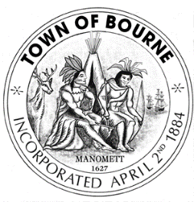
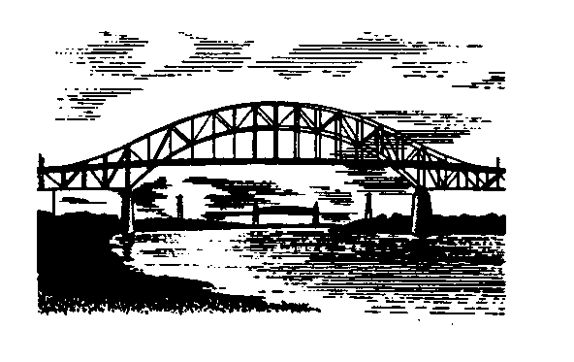
TOWN OF BOURNE
24 Perry Avenue
Buzzards Bay, MA 02532

Local Emergency Planning Committee

Meeting Posting

Date: May 4, 2016
Time: 4:30 pm
Location: Bourne Veterans Memorial Community Building
239 Main Street, Buzzards Bay, Ma

Agenda

- Call to order
- Attendance -Introduction of members
- Acceptance of Minutes- December 2, 2015 and March 9, 2016 meeting
- Hazard Mitigation Plan update
- COOP planning update
- Committee members comments/requests
- Public Comment
- Set next meeting date
- Adjournment

Charles K. Noyes
Director

