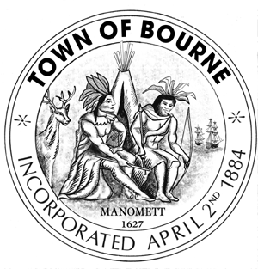
TOWN OF BOURNE
BOARD OF HEALTH
24 Perry Avenue
Buzzards Bay, MA 02532
Phone (508) 759-0600 x1513
Fax (508) 759-0679
Terri A. Guarino
Health Agent

MEETING NOTICE

Board, Committee, or Commission: BOARD OF HEALTH

Schedule of Meeting

Date: Time: Place:
Bourne Town Hall
May 25, 2016 7:00 P.M. Lower Conference Room
24 Perry Avenue
Buzzards Bay, MA 02532

AGENDA ITEMS:

- 576 SHORE RD – Lawrence Perrault – Request variances to construct a chicken coop and run area for 4 hens – 62 ft variance from his own dwelling and a 40 ft variance from the north lot line.

- Title 5 Variance/ Waiver Packets for Board of Health hearings—Review and possible vote.

- APPROVE THE MINUTES – APRIL 13, 2016 and APRIL 27, 2016 which were CONTINUED from the meeting dated May 11, 2016.

- APPROVE THE MINUTES – MAY 11, 2016 and MAY 16, 2016

Signed:
Title: Health Agent
Date: May 20, 2016
cc: Board of Selectmen/ Town Clerk

