ARTICLES OF THE WARRANT

FOR THE

BOURNE

SPECIAL TOWN MEETING

MONDAY, OCTOBER 19, 2015

7:00 P.M.

BOURNE HIGH SCHOOL AUDITORIUM
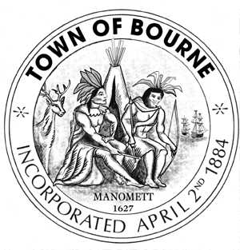

Article 1: To see if the Town will vote to amend the existing Zoning Map of the Town of Bourne by removing from R-40 and placing in B-2 the land in the village of Cataumet identified as Parcels 67, 68, 69, 70, 71, 72 Bonnie Land and the easterly portion of Anastasia Lane on Map Bourne Assessors Map 52 owned by the Woodland Realty Trust. Said land to be rezoned being designated by a blue line on the copy of the assessors map, a copy of which is on file with the Town Clerk, or to take any action in relation thereto.
Sponsor – Bonnie Wing and others

Article 2: To see if the Town will vote to appropriate a sum of money for the purpose of the payment of unpaid bills from a previous fiscal year that are legally unenforceable due to the insufficiency of appropriation or take any action in relation thereto.
Sponsor – Board of Selectmen

Article 3: To see if the Town will vote to amend the vote taken under Article 4 (Sewer Budget) of the 2015 Annual Town Meeting, or take any action in relation thereto.
Sponsor – Board of Sewer Commissioners

Article 4: To see if the Town will vote to raise and appropriate or transfer from available funds a sum of money to amend the vote taken under Article 6 (Reserve Fund) of the 2015 Annual Town Meeting, or take any action in relation thereto.
Sponsor – Board of Selectmen

Article 5: To see if the Town will vote to amend action taken under Article 3 (Annual Budget) of the 2015 Annual Town Meeting, and as necessary, to raise, appropriate, transfer or borrow funds for the purpose of supplementing departmental expenses and/or to reduce certain departmental expenses or otherwise amend said vote, or take any other action in relation thereto.
Sponsor – Board of Selectmen

Approved: September 30, 2015

BOARD OF SELECTMEN

_________________ _____________________
Stephen F. Mealy Donald J. Pickard

_________________ ______________________
Michael A. Blanton Peter J. Meier

________________
Donald E. Ellis

Barnstable, ss. Bourne, Massachusetts

By virtue of the Authority vested in me, I have this day posted a true and attested copy of this warrant in the Bourne Veterans’ Memorial Community Center, Bourne Town Hall and in all the post offices in the Town of Bourne viz: Buzzards Bay Post Office, Bourne Post Office, Monument Beach Post Office, Pocasset Post Office, Cataumet Post Office, Sagamore Post Office, and the Sagamore Beach Post Office.
Dated this ________________day of ____________________, 2015

_______________________________
Constable

Received in the Town Clerk’s Office _____________________

_______________________________________
Barry H. Johnson, Town Clerk

