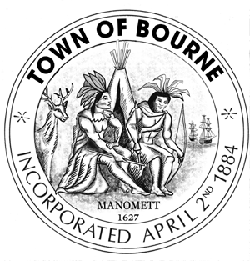
Bourne Human Services Committee

Meeting Notice

Date: Tuesday

December 15, 2015

Time: 4:00 P.M.

Location: COA Conference Room
Bourne Veterans Memorial Community Building
239 Main Street
Buzzards Bay, MA 02532

AGENDA

- Approve minutes of previous meeting
- Resource guide- need to update for printing
- Update on FY 17 HS budget
- Program updates
- Topics for future meetings
- Next meeting date

____________________________
Lois Carr

December 10, 2015

cc: Town Clerk
Committee: Bombaci, Carr, Murray, Thurston, Stuart, Monteiro, Warren, Silvestro

