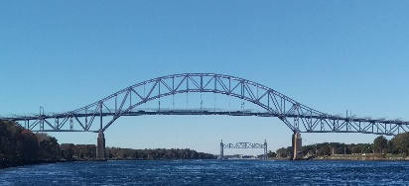
Board of Selectmen

Meeting Notice
AMENDED AGENDA

Date Time Location
August 2, 2022 5:30 PM Bourne Veterans’ Community Building – Rm 2
239 Main St., Buzzards Bay
Or virtually (see information below)
Zoom Meeting ID: 869 5775 5505 Password: 529740

All items within the meeting agenda are subject to deliberation and vote(s) by the Board of Selectmen.

5:30 PM Call Public Session to Order in Open Session

- Moment of Silence to recognize our Troops and our public safety personnel

- Salute to the Flag

- Vision: Bourne is a proud community that embraces change while respecting the rich heritage of the town and its villages. It is a municipality based on strong fiscal government with a durable economy that recognizes the rights of all citizens, respects the environment, especially the coastal areas of the community and the amenities that it affords. Bourne embraces excellent education, and offers to citizens a healthy, active lifestyle.

- Mission: Bourne will maximize opportunities for social and economic development while retaining an attractive, sustainable and secure coastline and environment for the enjoyment of residents and visitors. Through responsible and professional leadership and in partnership with others, Bourne will strive to improve the quality of life for all residents living and working in the larger community.

- Public Comment on Non-Agenda Items - Public comments are allowed for up to a total of 12 minutes at the beginning of each meeting. Each speaker is limited to 3 minutes for comment. Based on past practice, members of the Board are not allowed to comment or respond.

- Appointments: Discussion and possible vote to appoint Greg Berman to the Conservation Commission.

- Selectmen’s Business
  - Discussion and possible vote to accept the recommendation of the South Side Fire Station Committee to appoint Pomroy Associates to serve as the Owner’s Project Manager (OPM) for the project.
  - Discussion and possible vote to authorize the Town Administrator to enter into contract negotiations with Pomroy Associates to serve as the OPM for the South Side Fire Station project.

- Minutes: 7/20/21
- Next Selectmen’s meeting
- August 9th - Public Meeting for Phase II of the CWMP
- August 12th – Selectmen’s retreat
- August 16th – Selectmen’s meeting – regular business

- Adjourn

