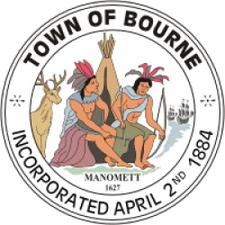
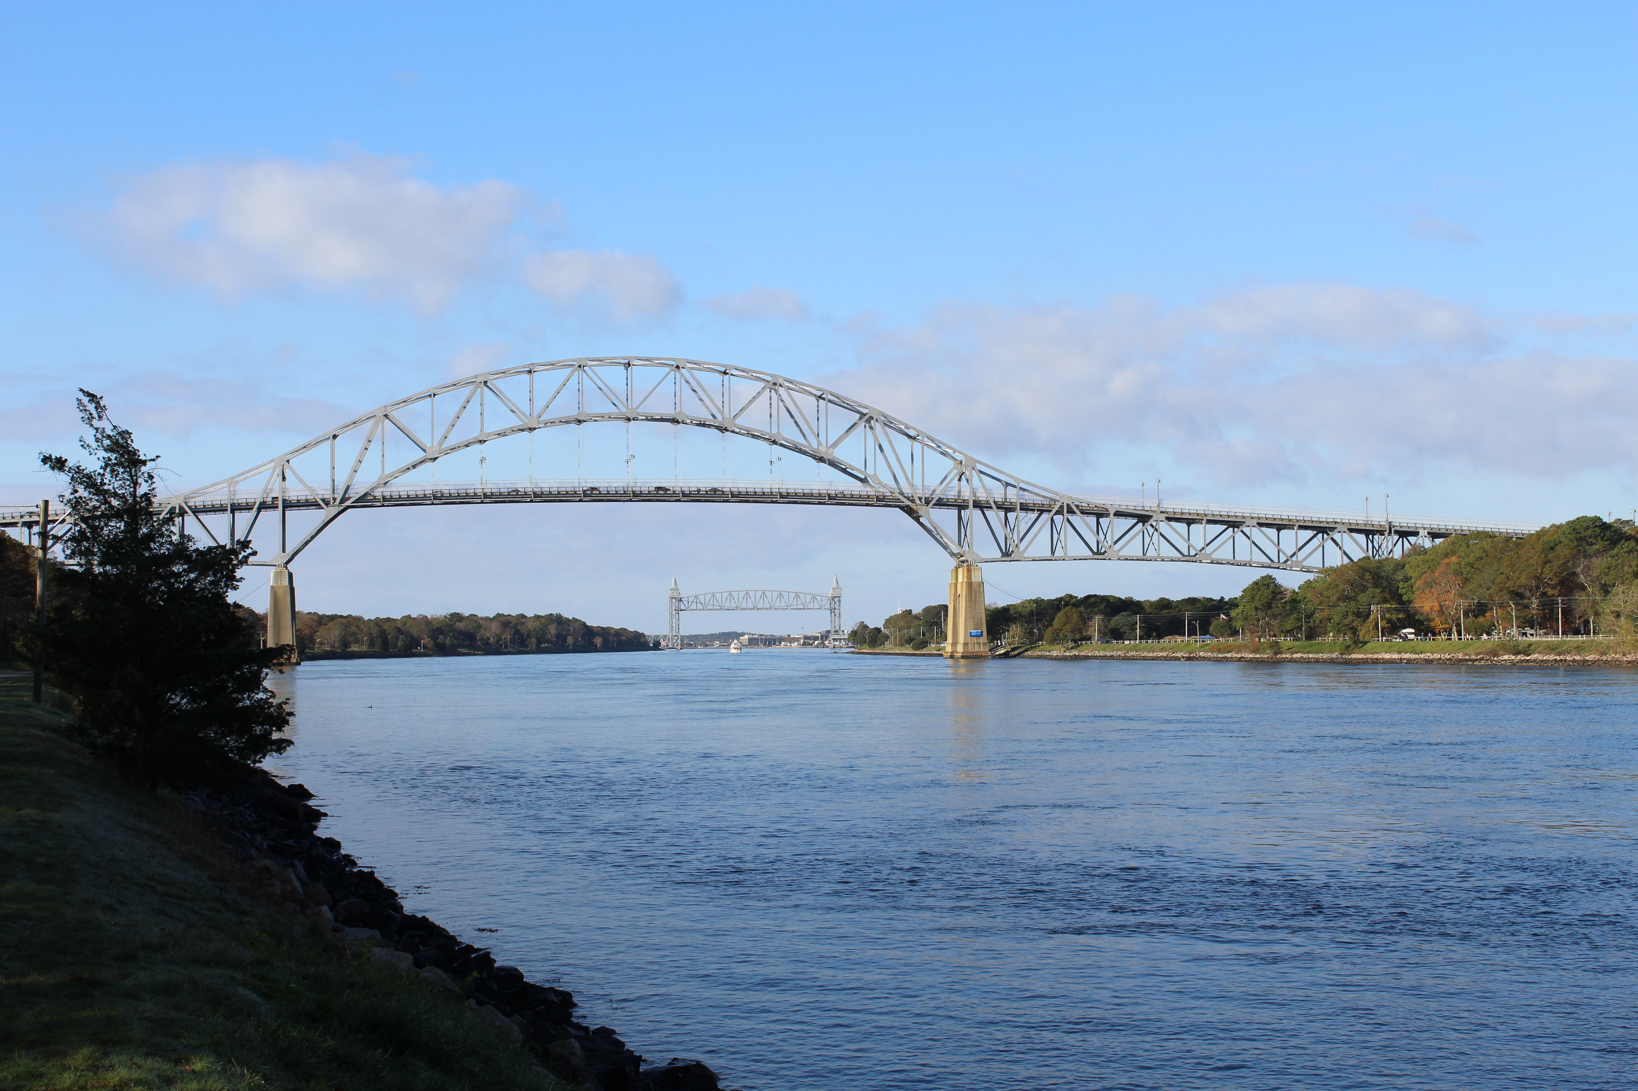
TOWN OF BOURNE
Town Administrator
24 Perry Avenue – Room 101
Buzzards Bay, MA 02532
www.townofbourne.com
508.759.0600, Ext. 1308

Anthony E. Schiavi, Town Administrator
Email: aschiavi@townofbourne.com

SCOPE OF WORK

OWNER: Town of Bourne
PROJECT NAME: Main Street Wet Well Cleaning
PROJECT MANAGER: Shawn Patterson, Director of Public Works
ESTIMATED COST: $15k
DATE: 16June2021

LOCATION OF WORK:

Main St. Pump Station behind 131 Main St., Buzzards Bay, MA

DESCRIPTION OF WORK:

- Remove all grease from wet well (12’ x 16’ area);
- Remove all grit and debris from bottom of wet well stations;

A wet well inspection is scheduled for June 29, 2021 at 0930 hrs. TBD.

MATERIALS AND PERSONNEL REQUIRED:

- Provide septic and vactor trucks adequate to complete all required tasks;
- Provide personnel certified in confined space and equipment as needed to perform the work required.

DATE OF COMPLETION:

The work should be completed no later than September 30, 2021.

Quotes may be sent via email to kthut@townofbourne.com or Town Administrator, 24 Perry Ave., Buzzards Bay, MA 02532. Quotes will be received until July 8, 2021 August 4, 2021 at 2 pm at which time they will be evaluated.

