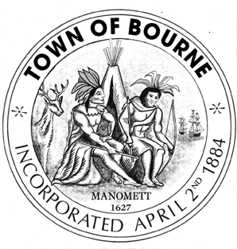

Board of Sewer Commissioners

Meeting Notice

AGENDA

Date Time Location
Tuesday 6:30 p.m. Bourne Veterans’ Memorial

June 23, 2015 Community Center
239 Main Street, Buzzards Bay

All agenda items herein may be subject to a vote by or other action of the of Board of Sewer Commissioners

Note this meeting is being televised and recorded. If anyone in the audience is recording or video-taping, they need to acknowledge such at this time

Call to order

- Request permission to connect into town sewer system - 39 Buttermilk Way, Buzzards Bay

- Sewer Wastewater Advisory Report

- Other Business

- Future Agenda Items

- Adjourn

