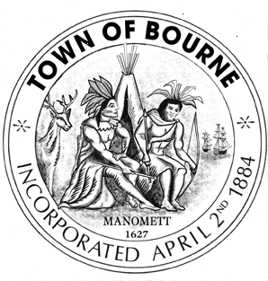

Board of Selectmen

Meeting Notice
AGENDA

Date Time Location
Tuesday 7:00 P.M. Bourne Veterans’ Memorial

July 21, 2015 Community Center
239 Main Street, Buzzards Bay

Note this meeting is being televised and recorded. If anyone in the audience is recording or video-taping, they need to acknowledge such at this time.

All items within the meeting agenda are subject to deliberation and vote(s) by the Board of Selectmen.

7:00 p.m. Call to order in Open Session

- Moment of Silence for our Troops and our public safety personnel
- Salute to our Flag
- Public Comment on Non-Agenda Items
- Correspondence
- Continuation of Request for temporary easement for Mann Farm Turbines off Head of the Bay Road
- Selectmen’s Business
- Town Administrator’s Report
- Selectmen Reports
- Other business that may legally come before the Board
- Adjourn

Future Agenda Items

- Update by Cape RTA regarding the Cape Flyer Platform and Siding on south side of Canal
- Reduction of Energy Committee Membership
- Appointment of MBTA Representative
- Discussion of Public-Private Partnership (3P) as it relates to the funding of a possible Third Canal Bridge
- Cape Canal Area Transportation Study Update
- Town Organizational Chart
- August 5, 2015 Selectmen’s Goals Workshop

