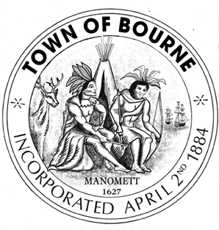
Board of Selectmen

Joint session with

Finance Committee and

School Committee

Meeting Notice

AGENDA

Date Time Location
Tuesday 7:00 p.m. Bourne Veterans’ Memorial

August 18, 2015 Community Center
239 Main Street, Buzzards Bay

Note this meeting is being televised and recorded. If anyone in the audience is recording or video-taping, they need to acknowledge such at this time.

All items within the meeting agenda are subject to deliberation and vote(s) by the Board of Selectmen and Finance Committee.

7:00 p.m. Call to order Joint Meeting of Finance Committee, School Committee and Board of Selectmen

1. State Office of Campaign and Finance presentation on Do’s and Don’ts regarding Overrides, what
Employees can and cannot do regarding the Override Question, forming, using Ballot Committees.

2. FinCom/BOS/School Committee Review of two new Sources and Uses:

a. Sources and Uses with Override
b. Sources and Uses with reductions based on input from July 28th and year end

3. Fire Department Budget Adjustments

4. Review and Discuss Community input and alternatives

5. Board of Selectmen Third, final reading of Financial Policy and potential vote for engrossment.

6. Other business of the joint committee meeting

7. Adjournment

