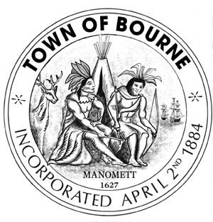

CAPITAL OUTLAY COMMITTEE

Meeting Notice

Date Time Location
Thursday 7:00 PM Bourne Veterans’ Memorial March 3, 2016 Community Center
239 Main Street
Buzzards Bay

If anyone in the audience is recording or video-taping, they need to acknowledge
such at this time.

AGENDA

- Call meeting to order

- Review available funds and fund balances in waterways, capital stabilization, etc.

- Discuss and vote FY17 capital recommendations

4) Such other business that may legally come before the Committee

“The listings of matters are those reasonably anticipated by the Chair which may be discussed at the meeting. Not all items listed may in fact be discussed and other items not listed may also be brought up for discussion to the extent permitted by law.”

__________________________
Mary Jane Mastrangelo
Chairman

Date: February 29, 2016

