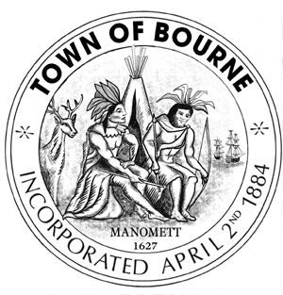

CAPITAL OUTLAY COMMITTEE

Meeting Notice

Date Time Location
Thursday 7:00 PM Bourne Veterans’ Memorial March 5, 2015 Community Center
239 Main Street
Buzzards Bay

If anyone in the audience is recording or video-taping, they need to acknowledge
such at this time.

AGENDA

- Call meeting to order

- Town Administrator’s recommendations

- Discussion on debt service

- Approval of minutes: February 12, 2015

- Future Meeting Topics

- Such other business that may legally come before the Committee

“The listings of matters are those reasonably anticipated by the Chair which may be discussed at the meeting. Not all items listed may in fact be discussed and other items not listed may also be brought up for discussion to the extent permitted by law.”
__________________________
Mary Jane Mastrangelo
Chairman

Date: March 2, 2015

