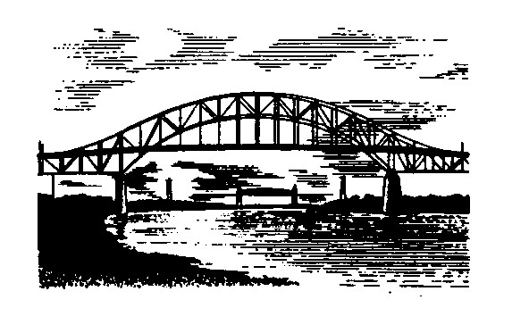
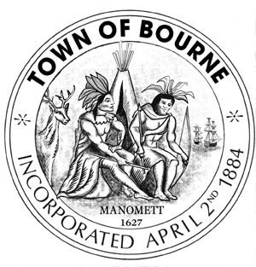

CAPITAL OUTLAY COMMITTEE

Meeting Notice

Date Time Location
Wednesday 9:15 AM Bourne Veterans’ Memorial
January 25, 2017 Community Center – Room 2 239 Main Street
Buzzards Bay, MA 02532

If anyone in the audience is recording or video-taping, they need to acknowledge
such at this time.

AGENDA

- Call meeting to order

2) Buzzards Bay Park Funding and Recommendations

- OPM Discussion – relative to Police, Wastewater and Buzzards Bay Park

- Planning monies discussion – relative to Wastewater

- Additional information/review on requests that have been reviewed

6) Public Comment

7) Such other business that may legally come before the Committee

“The listings of matters are those reasonably anticipated by the Chair which may be discussed at the meeting. Not all items listed may in fact be discussed and other items not listed may also be brought up for discussion to the extent permitted by law.”

__________________________
Mary Jane Mastrangelo
Chairman

Date: January 19, 2017

