**TA** Tom Guerino

**Selectmen**

Stephen Mealy, Excused

Don Pickard, Vice-Chairman

Michael Blanton, Clerk

Don Ellis

Peter Meier

Note this meeting is being televised and recorded. If anyone in the audience is recording or videotaping, they need to acknowledge such at this time – Michael Rausch Bourne Enterprise.

All items within the meeting agenda are subject to deliberation and vote(s) by the Board of Selectmen.

**Documents**

**Meeting Called to Order**

Vice Chm. Pickard called the meeting to order at 7:00 pm.

**Moment of Silence for our Troops and our public safety personnel /Salute the Flag**

**Public Comment – Non-Agenda Items**

Mr. Nelson wanted to talk about the proposed 2.3 million dollar railroad station and siding on the south side of the canal. His premise was that there was no way the Cape Flyer could justify the expense to build that project. If the railroad station was built on the south side the Cape Flyer would use it. Mr. Nelson also spoke about the commuter railroad station. His concern is what process is going to be used. The community should be involved in the process of determination with the MBTA and the other state agencies. The Selectmen, and the other committees in this town should have input. Other towns like Wareham and Sandwich should be involved. The broader region needs to be involved. Also the public needs to be heard. I would like to see this board present to the MBTA and the DOT, possibly a copy to the governor, and our representatives and senator going on record saying that is what we want to see happen, in terms of where this project goes.

**5) Correspondence**

Michael Blanton brought the committee up to date on the correspondence.

1. Letter we referred to last week from Mr. and Mrs. Jaworski with regard to a concern about the additional firefighters and the cost to the town.
2. Pete’s Marine appealing Harbormaster’s decision to DEP for non-renewal of a mooring permit in Phinney’s Harbor.
3. Letter of interest from Lori Cooney to serve on the Recreation Committee.

Tom Guerino believes we filled the opening, will have Mary looking into that and we will contact Mrs. Cooney.

Another piece of correspondence that I will submit for the record is from the Department of Fish and Game regarding the proposed Town of Bourne effluent pipeline connection to Guard wastewater system on the Reserve.

**6) Budget priorities – (30 minutes) – Long term plan review to assist in establishing**

Tom Guerino gave a brief overview on the budget

Linda Marzelli went over the **draft** budget FY16 to FY17 and the draft Free Cash Analysis FY2016.

Macintosh HD:Users:cellis:Desktop:Carole:Carole12:Bourne:Selectmen:1-12-16:2017LongTermProjections1.pdf







Michael Blanton questioned what has Governor stated regard to maintaining local aid?

Tom Guerino stated he thinks the Governor will make his commitment known at the MMA meeting. That is generally when the Governor lays out what his priorities are for the year prior to submitting the budget to the legislator. We think he will be understanding of the cities and towns based on the outreach they have done to the cities and towns.

Mary Jane Mastrangelo, Finance Committee Chairman, spoke about adding ISWM, OPEB and liability to their administrative costs. We have looked at having ISWM debt paid off by the time the landfill is non-operational, we should be looking at that with OPEB as well. It is dangerous for us to be thinking of paying OPEB for ISWM employees when ISWM in not operating anymore.

Tom Guerino stated Dan Barrett and Linda Marzelli will be getting together before the end of the month to look at the debt schedules.

Mary Jane Mastrangelo stated not sure if they do their calculation separate or if they put them in the same pool. Mrs. Marzelli stated they are all in the same pool. Mrs. Mastrangelo stated we may want to separate that so we can make sure we get that piece of money from ISWM. Looking at the budget, the long term financial planning model does a good job of estimating expenditures and the revenue side where we tend to be conservative. In future years when you start having accumulative effect of under estimated revenues and include nothing for turn-backs or additional revenues in terms of the free cash long-term projection. I think it makes the future years look worse than they are actually going to be. When you look beyond FY16 and FY17, but when you start getting to FY19 if there is a 1 million or 2 million dollars of revenue difference over those two years, then it will look like we don’t have enough money, but in fact we might.

**7) Budget discussion – progress of members regarding liaison work with Departments**

Peter Meier stated he and Michael Blanton and the Finance Committee Chairman met with the School Budget Subcommittee and it was eye opening. It will make it easier for us to understand when they present their budget in March. Michael Blanton stated the meeting was very informal. It was interesting to hear their methodology. They performed a SWAT analysis, which they do on a quarterly basis.

Peter Meier talked about lack of action from Cape Light Compact.

Don Ellis stated he met with the Chief of Police. They went through each line item. What he has requested is on line with the budget.

Don Pickard stated he was impressed with the Police presentation. Mr. Pickard and Mr. Ellis are also going to meet with the Fire Chief and Mr. Pickard will be meeting with Dan Barrett at ISWM.

Don Ellis stated he is also going to set up a meeting with DPW. Mr. Ellis also brought up how the Police Department has to operate in an antiquated building.

Peter Meier stated at the school committee meeting and in their agenda they have a statement that shows what the original appropriation is, what has been encumbered, and what is left outstanding. We need to have something like that for the town to have more transparency to see if there are any discrepancies. Mr. Guerino stated they can do that for the Chairmen. Linda Marzelli stated she can provide that to them and questioned do you want them quarterly or monthly.

Michael Blanton stated he and Mr. Meier are also going to set up a meeting with the Rec. Department, and talk about some of the issues with regard to the building, the programs, access to things like open gym, and if things can be adjusted or not.

Don Pickard stated as you look at the top of the budget by department you have the 2015 appropriated and the 2015 expended and 2016 appropriated and 2016 expended, and then you have the 2017 requested and adopted. Could we just cut off the 2015 and just use the 2016 and 2017. It should probably state 2017 department head request and 2017 Town Administrator. The Department head submit their budget to you (Mr. Guerino) and you make a recommendation to the Board; then in another column 2017 Selectmen. If you did away with 2015 maybe you could add those extra columns. That way the Selectmen can comment on it. Mr. Pickard also stated it looks like the lifeguards are being cut. Is there a way to do other cuts to keep the lifeguards? It’s the department heads that make the request; the Town Administrator makes the recommended cuts; and Selectmen should have a column. At some point in time would you provide to us what all departments have for levels of staffing and when you have a vacancy you can put vacancy.

Don Ellis stated he is concerned because we are a seaside community, how can we get rid of lifeguards; you won’t be able to teach the kids how to swim. Mr. Guerino stated swimming lessons will be offered on a fee based system the way they have been offered for years. If the Board of Selectmen decide they want lifeguards at the beaches you need to make that determination before the town meeting in February, because we have to have money in the budget in February to recruit and hire in May and June.

Peter Meier stated this is the perfect time for the Board members to list their priorities.

Tom Guerino stated yes; that would be helpful. The sooner we can set prioritization the better we will be able to make those adjustment to reflect the Selectmen’s prioritizations. Swimming lessons will be held at Monument Beach at a fee like they have been.

Michael Blanton questioned if we have history of what costs are and what they have been historically, we should be able to forecast what it will be for this year. Mr. Guerino stated yes they can get those numbers. Don Pickard suggested to Mr. Guerino to consult with Mr. Mealy to see if we can block out 15 minutes at the next meeting for the selectmen to come forward with their priorities, to make you aware.

Mary Jane Mastrangelo spoke about taking out the FY15 column. It is important to keep that column because that is your complete budget history. Also keeping the appropriations and actual is important, because when you go through the budget history you can say this is what was appropriated and this is what was actual, especially when you look at the three year history turn-backs. The Finance Committee uses the budget history. For the total budget amounts, I would like the totals for the school department to be included in the budget report. Mrs. Mastrangelo also said the Charter says the Board of Selectmen and the Finance Committee will give their votes in the voter handbook on every item.

**8) Selectmen’s Business**

* 1. **Ratify inter-municipal agreement with Sandwich related to Beach Stickers**

Don Pickard read the Summary of the Proposed Bourne/Sandwich Sticker Reciprocity

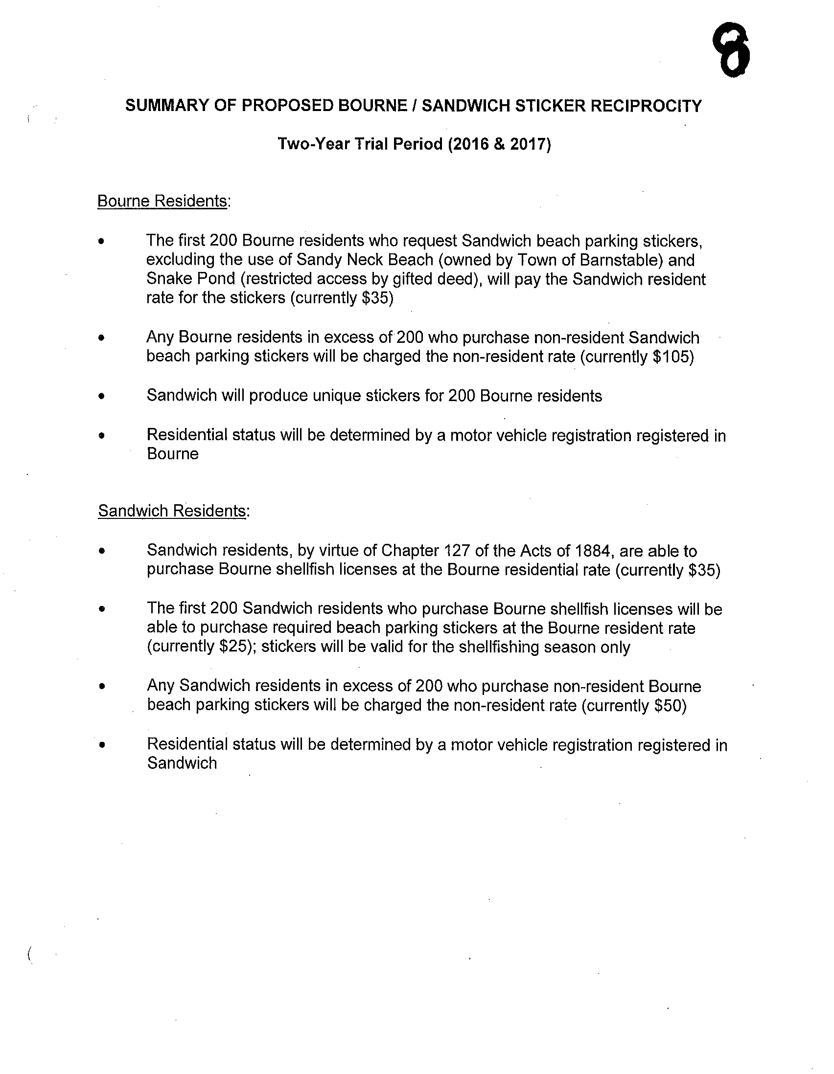

**Voted** Don Ellis moved and seconded by Michael Blanton to ratify this agreement between the summary of the Proposed Bourne/Sandwich Sticker Reciprocity.

Jim Mulvey questioned the rate for senior citizens. Tom Guerino stated that was not considered; the rate in Sandwich is the $35 rate the issue of senior stickers was not discussed relative to the Sandwich resident rate, it will be a $35 rate.

Vote 4-0.

**9) Town Administrator’s Report**

Tom Guerino stated we are part of the county bid for gasoline, and given that the prices right now are favorable, the county is going out to bid early this year for the gas so it can be bought or reserved in bulk at this rate. We are applying for the DLTA grants to try to acquire the additional $70,000 that is needed out of the $190,000 that is needed for the sewer study that we are doing for the 100,000 gallon plant here. The documents that you have, both the draft full budget you received on Friday and the numbers Linda has provided tonight, are subject to substantial modification as we move this forward. The bottom line may not change much relative to the departmental budgets. There are a lot of things in flux right now. Those numbers will be refined on a regular basis. Mr. Guerino also stated there is a storm water grant through the Buzzards Bay Action Committee that has been recently brought forward by the BBAC. Brendan Mullaney is going to be looking at it; he will meet with the Storm Water Committee and Local Pollution Committee. It appears that it will take some effort by DPW on monitoring things, but DPW thinks they can. Brendan Mullaney and George Sala will be at the next meeting of this group to discuss it so we can decide whether we move forward or not. It looks like something we may want to favorably do. The Executive session this evening that had to be canceled, we may have to have a meeting to discuss a couple of things, one of which is the collective bargaining and some contracts. If we can set a time that we can put a daytime meeting together, it would be appreciated. If we make some changes we have to move in a fairly expeditious manner.

**10) Selectmen’s Reports**

* + 1. **Goals – Update by Mr. Blanton and Mr. Meier**

Don Pickard stated we are going to defer the Selectmen’s report item a goals – update by Mr. Blanton and Mr. Meier, at their request. They will have that on the next Tuesday’s agenda.

Peter Meier spoke about Fox 25 News being at the Sagamore Fire Station earlier today, to recognize the Bourne Fire Department for what they do for the community. It is part of their Firehouse Fridays.

Michael Blanton attended the flag raising of the new sovereign territory for the official reservation area for the Mashpee Wampanoag Tribal Nation. Close to us now are the territory in Mashpee and the territory in Taunton. The town of Mashpee and the city of Taunton will be engaging with the tribe in inter-municipal inter-tribal agreements. We should pay attention to how those inter-municipal tribal agreements take place between the neighboring towns and the nation.

Don Pickard stated he was at Market Basket on Sunday and the CEO of Market Basket was standing in one of the isles with his daughter, who is also with the company, greeting some of the customers. I thanked him for his generous donation towards the COAs.

**11) Other Business**

The next Bourne Selectmen meeting will be on Tuesday, January 19th at 7:00 P.M.

**12) Adjourn**

**Voted** Peter Meier moved and seconded by Michael Blanton to adjourn. Meeting adjourned at 8:26 pm. Vote 4-0.

Respectfully submitted – Carole Ellis, secretary.