TA Tom Guerino

Selectmen
Stephen Mealy, Chairman
Don Pickard, Vice-Chairman
Michael Blanton, Clerk
Don Ellis
Peter Meier

Note this meeting is being televised and recorded. If anyone in the audience is recording or videotaping, they need to acknowledge such at this time – Michael Rausch Bourne Enterprise.

All items within the meeting agenda are subject to deliberation and vote(s) by the Board of Selectmen.

Documents

Meeting Called to Order
Chm. Mealy called the meeting to order at 7:20 pm.

Moment of Silence for our Troops and our public safety personnel /Salute the Flag

Public Comment – Non-Agenda Items

Mrs. Karen Gibides – Buzzards Bay
Mrs. Gibides wanted to publically comment on her recent observations regarding Future Generation Wind. Attended the Board of Health meeting last week and believed that board is working with their hands tied behind their back. She brought up concerns related to how the town was handling the legal aspect of the case and that in her opinion, the time delays regarding the prosecution of the case. She also indicated that many residents near the turbine site believed were not being protected by the town.

Stephen Mealy reminded the board we are unable to debate comment made under public comment, but will provide the following; there was a meeting last week between several Board of Health members, Board of Selectmen member, Town Administrator, and both Town Counsels. There is another meeting scheduled next week.

5) Correspondence

Michael Blanton brought the committee up to date on the correspondence.
- Letter of interest from Carol Lynch, of Pocasset, to serve on the Capital Outlay Committee
- Letter of interest from Elizabeth Barlow to serve on the Human Services Committee
- Eversource Energy is giving notice of planned and scheduled vegetation maintenance work on the transmission of right-of-way.
- Detective John Doble submitted a letter that he will be retiring on April 1, 2016 after 35 years of service to the Bourne Police Department.

6) Town Administrator FY 17 Budget Message

Tom Guerino read the FY17 budget message
As required by the Town of Bourne Charter, I am forwarding the FY 2017 Budget Message. This Message includes a summation of projected revenues, anticipated expenditures and presents a balanced budget for FY 2017. The main message in this introductory paragraph is simple and straight forward: The Override vote in October of 2015 FAILED. The outcome was close, but it FAILED. Cuts have been made. The municipality is functioning to the best of its ability but is not functioning at its’ best. Town Hall is too short staffed, as is the DPW. Other departments are barely hanging on. And until there is a new infusion of money this downward trend will continue. The Bourne School Department is in need of help. All departments are doing more with less and have been creative in trying hard to offer as many services as possible. Changes have some citizens angry. The truth is no-one is satisfied nor comfortable with the current state of program and service offerings. This includes elected leaders, municipal staff and administration or townspeople.

There has been outcry by many in the community that programs have been reduced, adjusted or have new fees attached. The fact of the matter is that these necessary changes were well forecasted and warnings of necessary changes were loud and clear by leaders of the community for months before the vote. There is a lot of "cut the budget, but not my program" talk out there.

Some have called for large infusions of cash to the current budget due to some better than expected revenues being derived in the current year. While we often make minor adjustments to budgets during the course of a given fiscal year (as we are proposing in February of this year), as a community we have never spent great sums of money in a current fiscal year because of better than expected revenues. This cautious approach has what has been able to keep the Town afloat during turbulent times. The notion to spend “new” money in the year it was received after budgets have been set, is NOT sustainable in the long run. I remind all that in October, the voters told us as municipal official s to live within our means. This was echoed at the Autumn Special Town Meeting. It is now our job to do so, politically popular or not.

This budget is designed to work within the confines of this reality. It is not a budget citizens are accustomed to. New revenue sources will need to be ascertained after this upcoming fiscal year. And by New sources, I mean another override attempt at a time in the near future. The timing of such to be determined by the Board of Selectmen, for FY 18. If this is not accomplished, staffing and programs within the municipal and educational areas of Bourne will continue to fall and in some cases, fail. It appears that the municipality will be forced to reduce budgets by an amount approximating $1.3 - to $1.8 million in FY 18, based on current projections and current policy constraints. This means school and municipal departmental losses, with some departments likely to be eliminated. Police and Fire will also be subject to staffing reductions.

I bring forward this balanced budget again with a bit of a blind spot. This budget message is earlier than the last several years and the Governor's budget is not due until the end of this month. It is anticipated that local aid will remain flat which could mean a bit more or less actual "cash in the coffers" depending on state and other assessments. There is some positive news as it appears that the UCRTS assessments will finally level out after many years of substantial increases. Additional cost controls and cost shifts in the health insurance programs will again prove to be helpful and rates rise less than the current industry standard by a substantial amount. Should new changes not be considered, this budget will be substantially out of balance and further reductions to all Town funded departments, including schools will have to be considered.

I have been cautioning the Elected/Appointed leaders that we are coming to a time wherein we can no longer rely on departmental turn backs and our conservative approach to revenue estimates to manage the pot holes we encounter in the budgetary process. I expect nonsalary vacancy related turn backs to be extremely limited. I take pride in the fiscal prudence of Town Departments. This previously praised and championed approach suddenly came under fire when the reality of a failed override came due.

The Town has been extremely frugal for a long time and staffing is overall at a minimum. The truth of the matter is many offices within the Town and School Departments are dealing with limited functionality due to staff shortages. Our Planning, Inspections, Conservation, Engineering, to some degree Health are not able to provide full service and/or full coverage as most departments are with only one person per function or one person departments. When many departments of one are out due to allowed vacations, professional development requirements or illness, there is no one to take on the tasks and duties. The estimated lost time to citizens is 286 workdays. This equates to delayed plans review, loss of citizen technical assistance and citizen inconvenience causing multiple visits to Town Hall. There are many areas within the Bourne School Department that face similar difficult circumstances.

There is no place to cut in order to "show" frugality. Those days have concluded. The last round of reductions due to the result of the failed override coupled with the reductions made just before the annual town meeting in 2015, have cut to the bone and beyond. Bourne Public Schools are funded at the minimum level and some could justifiably make the argument, below the minimum level. The municipal non-public safety departments cannot endure more personnel reductions. Any further reductions in the budget will have to include public safety.

All Town Departments have again depicted a strong sense of fiscal restraint. These professionals work hard every day to bring the services the citizens and elected leaders demand at the least possible cost.

Our public safety and natural resource leaders continue to do outstanding work with tangible increased demand on their staffing and expertise. The participation in programs offered by the Library, Recreation Department and Council on Aging is increasing; however, fees are replacing what were formally town funded program expenses. Adjustments have been made and will be brought forth at the upcoming Special Town Meeting in February to keep the COA bus driver, stave off loss of accreditation and keep the CLAMS network, etc. current at the library for the FY 17 budget. Citizens use these services and they are as important to large constituencies as our schools and public safety departments are to all.

The Town’s Public Works, and Landfill divisions continue to provide excellent service while we transition to new ways of conducting business. The Facilities Department is saving the town money on a daily basis and is trying to keep the long neglected brick and mortar piece of the organization in shape. The demands of State and National Government mandates are increasing and our ability to respond remains stagnant.

There are areas of good things happening that should be noted. We are beginning to think forward in a municipal, fiscal, and management sense. We have begun the system of priority based budgeting. While a bit delayed due to the work leading up to the override vote and the travails to cut the budget after the failure thereof, initial meetings have been concluded and departments have worked on the first phases of the program. The new DPW complex has been completed and is something the entire Town should take pride in accomplishing. An open house will be scheduled in the spring. The School and Police Facility building Committees are up and running. Communication between the Town Administration and School Department and the elected Chairs of BOS and School Committee are better than they have been for years. It helps all of us when frank and clear discussions about departmental needs are frequent and candid.

The ISWM Futures Working Group continues to work with the Town’s hired and elected leadership to move many projects and ideas forward to assure a long life at the landfill site. The Financial Projects Working Group, as appointed by the Town Administrator, has served much of the purpose it was charged with and a different iteration of a similar group is being formulated. The Town has a more advanced set of financial policies as a result of a collaborative process.

Now to the Budget itself:

As stated earlier in the message, the Town is no longer in a position to continue most operations in a similar manner for the upcoming year. The following slides will show each area of town Government and the proposed increases. Note, this also assumes recommended amendments to the FY 16 Budget as described to the Board of Selectmen on January 12, 2016. Any additional changes to the FY 16 Budget beyond these few modifications will alter the numbers below. At the end of this you will see that continuing on, even after all of the FY 16 and FY 17 reductions will leave us seriously upside down in FY 18. This budget also takes into consideration the requirements of the Selectmen. There are no new positions requiring additional funding.

Stating Departments are "up" or “down" in this current climate is really not a factual way to comment on the budget. Function is level or reduced from the point of the failed override and reductions required from that. Adjustments have had to be made where some reductions were too severe or there was unanticipated fallout. I think it best if we look at where we have come from and where we appear to be going.
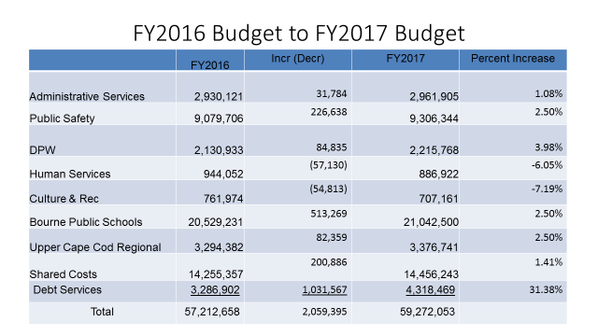

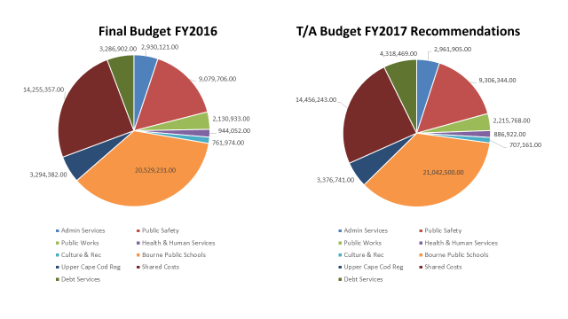

***Additional Notes: 06/01/2015. The Board of Selectmen required additional budget reductions prior to Town Meeting in May of 2015. In excess of $225,000.00 was reduced from the current operating budget prior to the override vote in 2015.

The TA PROPOSED Budget understands that the current revenue forecast is limited. It is anticipated that State aid will remain basically level funded (GOV -House 1) overall and state/county assessments will rise resulting in a net loss as compared to the prior year. However, even given the past several years of prudent and conservative revenue forecasts, dependable and professional departmental budget management of expenditures and sophisticated, professional administrative management, the Town is now in difficult position by simply meeting and not exceeding its’ own established policies for reserves. The Town will hold approximately 11% (at policy) of the proposed FY 2017 budget in savings after the use of approximately 1 million in free cash for budget offset, in adherence with the new policy. I further recommend that the absolute minimum amount of cash be used to fund the Capital Improvements budget.

The budget presented will continue the swim lesson program on a fee for service basis. And, as was clearly stated in the multiple public forums leading up to the override vote this past October, in this proposed budget, Lifeguards at the two beaches will be eliminated once again. Note that the Recreation Department has no budgetary expense line items. These were eliminated when the override failed. All programs are fee based and recreation staffing is at a minimum

The Town’s most recent borrowing rate on bonded debt was net less than 2 %. We must take advantage of these continual but time limited low rates. A new Police Facility must be the priority in consort with a new elementary school project. Both must be accomplished and the Town leaders must work together to achieve success for these two important facilities.

Notwithstanding the above necessary changes, this budget meets the requirements of the Townspeople as a result of the failed override.
Fiscally Responsible use of Reserves - The Town utilized the reserves to fund portions of the FY 2016 current budget, pursuant to the Financial Policy. With the new policies in place we are limited to use only approximately $1,004,353 for the FY 2017 budget as currently presented.

Thus, the town must be prudent to protect reserves at policy to help maintain a positive bond rating. The Stabilization Account is $3,530,881 and there is currently approximately $260,000 in Capital Stabilization. Below, please find a historic view of free cash and stabilization balances.

HISTORY OF FREE CASH

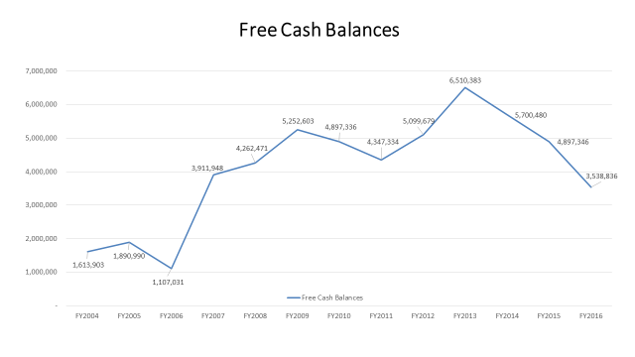
HISTORY OF STABILIZATION
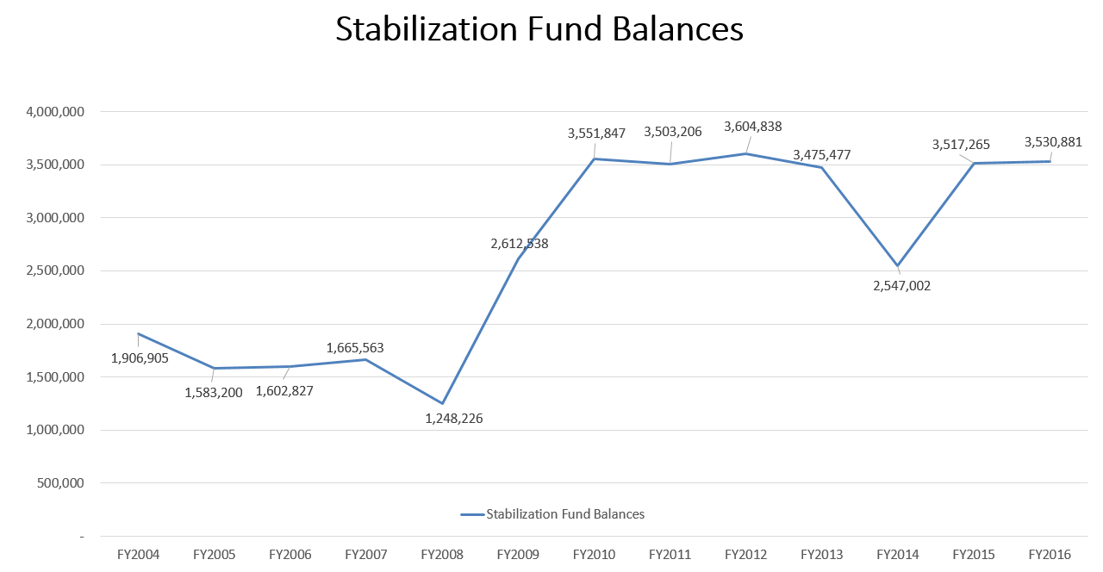
Based on the assumptions made within this budget the Town remains within the policy guidelines established. The use of the reserves as prescribed ($1,004,000.00) will do much to help in appropriate funding levels for the School and Town Government. It will also continue to protect the current bond rating provided by Standard and Poor’s. As the Board is aware the AA “Stable” bond rating provides the Town more favorable rates on items and facilities purchased via borrowing.

For the record I will repeat last year’s message and the year before that: Most departments remain understaffed while the complexities of running a municipal business continue to grow. We must as a community address the most critical staffing needs as depicted earlier in this document.

Override Recommendations

An override is necessary for FY 18 and preferably before. It is up to the Board of Selectmen determine the timing of such.

Enterprise Funds

ISWM

The recommended ISWM FY 2017 expenditure budget represents a continuation of the significant change in how the department will be successful moving forward. The long term contract with Covanta will assure stability over the long run and reduce many of the odor and other potential environmental problems that could occur is this type of operation. The current Landfill Futures Working Group has done an exceptional job in scoping future endeavors for the ISWM department and is to be so commended. Implementing Single Stream recycling and the potential purchase of land south of the existing facility will further enhance the stability and long term viability of the department.

Sewer Department

The Sewer Department continues to function with minimal labor and equipment costs. Costs associated with this budget are largely a function of costs assessed by the Town of Wareham for materials used in the treatment process at the Wareham Plant. Note that the underground infrastructure and associated pumping stations are old and will need ongoing commitment.

As was noted last year, obtaining timely information from the Town of Wareham has been challenging. Steps by the Board of Sewer Commissioners to rectify this concern are underway.

BUDGETARY HIGHLIGHTS

This Budget Message also includes the following for the Board’s review and comment. While some may appear to be redundant from the text above it provides a numerical basis for the budget recommendations:

♦ Sources and Uses Chart estimates with Revenue & Expenditure Projections.

- Ambulance fees will be adjusted slightly due to new approved rates. We are proposing the use of this funding source to assist in offsetting some budgetary and capital items directly related to operations in the EMS division of the Fire Department.

- Town General Insurance rates are expected to rise modestly.

- PILOT funding is anticipated to be level.

- Chapter 70 Aid to education is expected to be stable.

- General Assistance to Cities and Towns is expected to be similar to last year's.

- While ISWM offsets remain stable for the upcoming year, the Town continues to utilize the money from the landfill in an appropriate manner.

- “New Growth” is estimated at $400,000.

♦ Debt Service Schedule and Analysis

- Debt service on existing non-exempt debt is appropriate for a community of this size and complexity. Note that there is a substantial increase in exempt and non-exempt debt this year as the Public works facility has been included in the payment schedule and permanent bonding of many non-exempt authorizations have been placed into a permanent bond issue.

GENERAL FUND BUDGET

Below, please see a Tax Levy summary of the growth allowed under Proposition 2 ½.
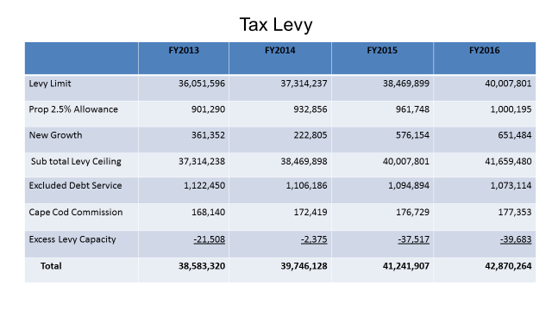It is my intention to continue to work with School and other Departmental leaders in an effort to achieve municipal efficiencies while holding to the current budgetary numbers, including adjustments made upward or downward as the Commonwealth’s budget picture becomes clearer. Also note that discussion regarding the State budget generally encompasses “State Aid”. We must also be very cognizant of “Cherry Sheet Assessments”. Please see a historical breakdown of Cherry Sheet Revenues and State Assessments.

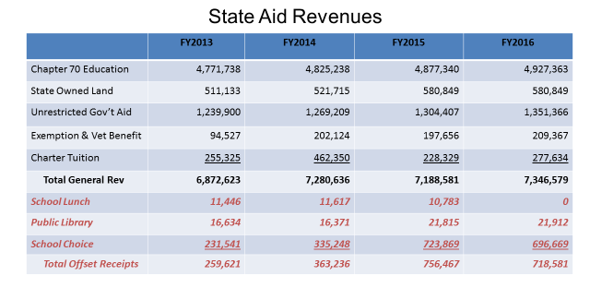

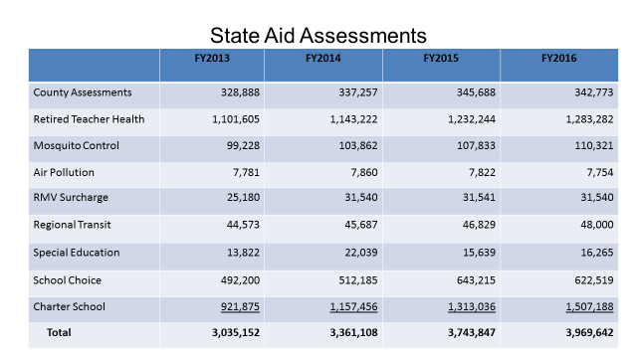

TOTAL FY 2017 General Fund Budget Including Capital Debt Service and Without Enterprise Funds is $59,272,053.

It is an annual challenge to construct a budget for presentation to the Town’s citizens. Numbers shift dramatically back and forth over the course of several months. Specifics from the Commonwealth will once again be held until the last possible moment allowed by law. Working figures from the Commonwealth have not yet arrived. I anticipate the need for several modifications to this budget proposal prior to printing in the Finance Committee handbook.

Again, without the strong willingness and candor by Bourne’s Department Leaders, finding the right balance of expenditures would have been much more difficult. Communication with Bourne School Department are frequent and most positive. The more we share information, successes and concerns, the better the Community is served. The Town is indeed fortunate to have the workforce and departmental leadership currently in place. It cannot be forgotten that the proposed budget has continuing implications to service delivery.

I would be remiss if I did not thank several people who have provided great assistance in preparing this budget and Budget Message. The Department Heads and employees have been instrumental in endeavoring “to make this budget work”. The Director of Finance is personally thanked for her continued supportive expertise, guidance and good humor, especially during this most difficult year. Ms. Marzelli’s unyielding commitment to the Town is unwavering.

I look forward to reviewing this budget with the Board of Selectmen, Finance Committee and Citizens of Bourne.

Respectfully submitted,

Thomas M. Guerino
Town Administrator

Don Pickard stated in the last two weeks I have meet with 3 department heads, Mr. Ellis and I met with the Fire and Police, and I met with ISWM. The common theme is the next place to cut is staff. There is no place to cut anymore except for staff.

Michael Blanton stated when he and Mr. Meier met with several department heads they heard similar things, the only place to cut is staff, and in many of these departments there is only one person on staff. Being able to look at anything that may be innovative is lost. That loss of innovation is going to end up resulting in less services, less attractive community, less attractive of life, which will effect property values, decline.

Don Ellis stated he had a meeting with DPW and it comes down to the only thing they can cut is personnel.

Peter Meier stated this budget is a budget of reality. This budget needs adjustments. These department heads did the best they could with the instructions that were presented by the Town Administrator. I disagree with some of what is being considered. The children and the elderly area going to be affected the most.

Stephen Mealy stated he has been very earnest to make sure we follow what the charter and the town bylaws asked for.

7) Selectmen’s Business
  - Review articles for Special Town Meeting
  - Sign warrant for the Special Town Meeting
  - Goals presentation and adoption – Mr. Blanton, Mr. Meier
  - Budget priorities discussion – FY 17

Tom Guerino handed out new articles dated 1/19/16 to the Selectmen because of typos.
Changed the wording on article 11 to stop the encompassing to try to limit the article.

ARTICLE 1. To see if the Town will vote, upon recommendation of the Community Preservation Committee, to appropriate, borrow or transfer from available funds a sum of money for engineering services; the reconstruction, and resurfacing of the existing OUTDOOR TRACK at JACKSON FIELD located behind the Peebles Elementary School, including incidental costs related thereto, said funds are to be expended under the direction of the Director of Business Services of the Bourne School Department and the Community Preservation Committee, or take any other action in relation thereto.
Sponsor – Community Preservation Committee

Mr. Mealy read Article 1
Barry Johnson went over Article 1
All of these funds that are being recommended at this town meeting or at any town meeting that involve Community Preservation Articles, the funds are derived from the 3% surcharge on everybody’s real estate tax bill. In no way it impacts on the operating funds for the community as well as a matching fund from the state. This project has been proposed by the Director of the School Business Department; it has also been endorsed by the School Department, School Administration, School Facilities Committee, as well as the recreation committee. The reason we are including this article is we want to meet the spring’s constructions schedule. The estimated total project budget is $675,000. The committee is going to recommend we borrow that sum of money, over a period of years. Under Chapter 44 section 7 sub-section 25 of the Mass General Laws we are allowed as a community to borrow for recreational outside activities of this particular nature; so in the motion that will be the reference to the statute. The committee has listened to the proposal and we have voted unanimously to recommend this to the town meeting membership on February 8th.

Don Ellis stated he would endorse this article. This track is in serious need of upkeep.

Don Pickard questioned reference to the borrowing, the Community Preservation Act will have to be voted again in 2020?
Mr. Johnson stated no, it can be revote; it can be left alone. It can be reviewed at the end of 2020. If the town voted to discontinue the CPA Program at the end of FY2020 the bond and debited nous carries forward to be paid off through the surcharge on everyone’s tax bill.

Peter Meier stated he supports this article. Will this be a long-term plan; would you consider other improvements to Jackson Field and would it come out of CPA?
Mr. Johnson stated if we do go into additional projects that would require going into another set of plans, which would cost more.

Voted Peter Meier moved and seconded by Michael Blanton to approve $675,000 for the purposes of article one, and the means will be to borrow.

Mr. Blanton questioned what materials will be used in the reconstruction and what is the life expectancy? Mr. Johnson stated probably for about another 25 years. The maintenance on it would not be required for about 8 to 10 years.
Vote 5-0.

ARTICLE 2. To see if the Town will vote to accept the provisions of Massachusetts General Laws Chapter 54, Section 16A permitting the Town Clerk to appoint the Warden, Clerk or Inspectors in circumstances where any of these persons are not present at the opening of the polls, in accordance with the requirements of this statutory section, or act anything in relation thereto.
Sponsor – Town Clerk

Barry Johnson, as Town Clerk, read article 2 and gave a brief background on the article. Very rarely we’ll get a call and need to find a replacement and still have to open the polls at 7:00. Under this statute the Clerk is able to appoint an additional poll worker at that time.

Voted Don Pickard moved and seconded by Michael Blanton to approve Article 2 based on the presentation by the Town Clerk.
Vote 5-0.

ARTICLE 3. To see if the Town will vote to accept an Easement from the Bourne Historical Society, Inc. to the Town, on terms and conditions deemed to be by the Selectmen to be in the best interest of the Town, for the purpose of constructing a trail and walkway from Aptucxet to the Town owned “Lyons” property as shown on a Plan of Land on file at the Office of the Town Clerk, or take any other action in relation thereto.
Sponsor – Open Space Committee

Barry Johnson, Chairman of the open space committee, went over Article 3.
The proposal under this article is to see if the town would vote to accept from the Bourne Historical Society an easement with terms and conditions that will allow us to construct a walkway from the Aptucxet Post property towards the canal side up to the Lions property. In the future we would like to put a gazebo. The first step is to ask the town to approve the easement.
Don Ellis stated he spoke to the chairman and the superintendent of the grounds and went over it with them. The Board of Historic Society is in full support of this.

Voted Don Pickard moved and seconded by Peter Meier to approval Article 3. Vote 5-0.

ARTICLE 4. To see if the Town will vote, upon recommendation of the Community Preservation Committee, to appropriate, borrow or transfer from available funds a sum of money for the following Community Preservation purpose: to restore and preserve the Civil War Soldier’s and Sailor’s Monument located in the front of Town Hall located at 24 Perry Avenue, Buzzards Bay, including costs incidental and related thereto, said funds are to be expended under the direction of the Town Director of Public Works/Facilities and the Community Preservation Committee, or take any action in relation thereto.
Sponsor – Community Preservation Committee
Historic Commission
Trustees of the Bourne Veteran’s Memorial Community Building

Barry Johnson went over Article 4. We appropriated a sum of money to restore the Civil War Soldier’s and Sailor’s Monument. We have a budget of $350,000. It is our anticipation that these funds will come from the undesignated fund balance of the Community Preservation Fund. The Community Preservation Committee has voted unanimously to recommend this project. George Sala stated as the Chairman of the Veterans’ Memorial Trustees we support this article.

Voted Peter Meier moved and seconded by Michael Blanton to approval Article 4 to transfer from the undesignated funds from the CPC in the amount of $350,000. Vote 5-0

ARTICLE 5. To see if the Town will vote to amend the Bourne Zoning Map by changing the existing Business 2 (B2) zoning district to Business 3 (B3), as shown on a map on file with the Town Clerk, or to take any other action in relation thereto.
Sponsor – Planning Board

Tom Guerino spoke briefly about Article 5. To change the height in the B3 district on how tall a building can be. The B3 district is primarily to the easterly side of the Bourne rotary.
Don Pickard suggested we put 5,6 & 7 on our next meeting agenda.

ARTICLE 8. To see if the Town will vote to raise and appropriate or transfer from available funds in the ISWM Enterprise Fund retained earnings or borrow a sum of money to be paid back from the ISWM Enterprise Fund, an amount equal to $1,100,000 for the purpose of funding a single stream recycling capital project that includes equipment modifications to Town collection vehicles, purchase of specialized curbside collection carts and containers for residents and municipal facilities and the production and distribution of educational materials or take any action in relation thereto.
Sponsor- Board of Selectmen

Jonathan Nelson gave a quick overview for Article 8. We are requesting $1,100,000 from out of ISWM retained earnings to fund the single stream and semi automated recycling project. This project would provide for the needed carts for residents, make some equipment updated and also some advertising dollars. Don Pickard questioned if this will come out of the enterprise retained earnings?

Mary Jane Mastrangelo, Capital Outlay Committee, stated the committee met on this article three times and voted at their last meeting to support this article. They talked about this article being paid for from ISWM retained earnings.

Voted Don Pickard moved and seconded by Peter Meier to approve the article. We can make a recommendation on the funding at the town meeting. Vote 5-0

ARTICLE 9. To see if the Town will vote to authorize the Board of Selectmen to acquire by purchase, gift or eminent domain a parcel of land owned by Red Wolf Realty Trust in the Town of Bourne designated on Bourne Assessors Maps as Parcel 5 on Map 32, approximately 12 acres in the area, for the purposes of the Department of Integrated Solid Waste Management Facility, on terms and conditions deemed by the Selectmen to be in the best interest of the Town, and to raise and appropriate, transfer from available funds or borrow, a sum of money for the purposes of this Article or act anything in relation thereto.
Sponsor – Board of Selectmen

Don Pickard briefly went over Article 9. We have the opportunity to purchase that parcel from the owner. It will extend the life of our landfill.
Tom Guerino stated the motion will have the amount; it is approximately 1.8 million dollars.
Peter Meier questioned are we allowed to raise and appropriate after the tax rate is set? Mr. Guerino stated you are correct, the motion will not allow for a raise and appropriate, and being ISWM it wouldn’t be raise and appropriate.

Voted Don Pickard moved and seconded by Peter Meier to approve Article 9 as presented.

Mr. Brian Lamay questioned how are we going to pay for clearing this land and grading it?
Don Pickard stated our ISWM crew and the Public Works crew would do it.

Vote 5-0

ARTICLE 10. To see if the Town will vote to appropriate, transfer from available funds, or borrow a sum on money for the purpose of funding the following capital improvement and capital projects, or take any other action in relation thereto.
Sponsor – Capital Outlay Committee
 | Description of Work |  | Amount
Fire Department
 | Ambulance Replacement |  | $260,000.00
 | Total |  | $260,000.00

Stephen Mealy read article 10.
Mary Jane Mastrangelo, went over this article. Mrs. Mastrangelo stated the Capital Outlay Committee met with the Fire Chef for his FY17 Capital plan, and one of the items is to replace ambulance A136. He wanted to do that before July 1st of this year because there are new regulations going in on July 1st that will increase the cost of an ambulance by approximately $50,000.

Don Pickard questioned this is to replace ambulance 136 which was suppose to be replaced at our annual town meeting in 2017. We have ambulance 135 replacement on order, when is that due? Mr. Guerino stated March or April. Mr. Pickard wanted to clarify we have ambulance 135 that is in service and awaiting a replacement in March. Is ambulance 135 still operating on a daily basis? Mr. Guerino stated yes it is still in service. Mr. Pickard stated he is opposed to this, and can’t see why we can’t wait until the Special Town Meeting within the Annual Town Meeting in May. It is prudent for us to remain as vigilant as possible and not replace this ambulance until the Special Town Meeting within the Annual Town Meeting. I don’t think this particular time is the time to do this. I am respectfully opposing it.
Don Ellis stated he agrees we can’t afford this at this time.
Mrs. Mastrangelo stated they were discussing increased concerns that were happening at the Pocasset Fire station. Her concern is that if we wait and we still need to replace the ambulance you are still paying more money for repairs and the cost to replace the ambulance is going to be more.
Don Pickard stated it wont go up that much if we just wait until May.
Tom Guerino stated that at the special or annual Town Meeting the funding mechanism will still be the same.
Michael Blanton agreed that deferred capital expensed do increase over time. In terms of fiscal prudent and restraint it may be a more fiscally prudent strategy to purchase it now than letting it get more expensive down the road. Within the override discussion we were going to maintain the commitment to public safety. By investing in our public safety equipment we maintain that commitment as well.

Voted Peter Meier moved and seconded by Michael Blanton to support the request for article 10 for a new ambulance in the amount of $260,000 from the Ambulance Fund. Don Pickard and Don Ellis opposed. Vote 3-2.

ARTICLE 11. To see if the Town will vote to appropriate or transfer from available funds a sum of money to supplement the FY2016 Regular Annual Expenses of the Town as voted under Article 3 (Annual Budget) of the 2015 May Annual Town Meeting and Amended under Article 3 (Annual Budget) of the 2015 October Special Town Meeting, or take any action in relation thereto.
Sponsor – Board of Selectmen
Town Administrator

Stephen Mealy read Article 11
Tom Guerino briefly went over Article 11. As we discussed at out meeting last week, there were some items we felt that needed to be adjusted. We have worked with the school department. In the town meeting warrant article you received on Friday, which has changed, the intent was to tighten that article up as much as possible. We talked about reinstating the bus driver at the Council on Aging for about $22,000.00. Helping out the library, enhancing theirs up to about $35,000.00. $7,916.00 into the Town Administrator’s Departmental Salaries & Wages. The non health insurance related bills we have received, that are over what the original budget is; we budget for $55,000.00. The school department has come in with a documented need of $139,916.00. We talked about booting up the snow and ice account to $150,000.00. In the warrant you received this evening I dated 1/19/16, we have changed the wording of the article to transfer from available funds a sum of money to supplement the FY16 Annual Expenses of the Town.

Stephen Mealy stated we originally specified an amount of $409,832,00 if that had appeared in the article would the town be able to spend more money than that? Mr. Guerino stated not into other line items, it would only be into those areas, because the article would be defined. Don Pickard questioned can you define available funds, where the money will come from? Mr. Guerino stated it will come from Free Cash. Don Pickard stated after the $409,832.00 is removed from Free Cash; where does that leave us with our policy? Tom Guerino stated we are still within policy.

Peter Meier stated he was one of the people that asked for this article to be stream lined. We have had discussions about this building being cut back. In my opinion it may have been a wise decision, but in reality this is the one building that serves all generations. The fact that we may have some discretionary income to look at getting this building open longer hours or back to the way it was before. It is something I think we should look at. Tom Guerino stated we were going to have some outreach people here after regular work hours. So folks that need those services would be able to come in after work.
Don Ellis stated his concern is the lifeguards at the beaches. We are a seagoing community and I am concerned about young people being at the beaches.

Stephen Mealy stated he wants to discuss the $409,832.00 and take a vote on that and then open further discussion for any additional adjustments.

Voted Don Pickard moved and seconded by Michael Blanton that the Board approve the amount of $409,832.00 for the preliminary pass for article 11 for the 2016 budget from free cash.

Stephen Mealy read the amounts.
Counsel on Aging Salaries & Wages for a bus driver - $22,000.00
Library Salaries & Wages - $15,000.00
Library Expense - $20,000.00
Town Administrator’s Departmental Salaries & Wages - $7,916.00
Non Health Insurance additions - $55,000.00
School Budget - $139,916.00
Snow & Ice Expense - $150,00.00
Total - $409,832.00 to be transferred from Free Cash

Vote 5-0.

Voted Peter Meier moved and seconded by Michal Blanton to take $18,000 from available funds for the purposes of supplementing the expenses/contract work to open the community building.

Tom Guerino stated for the option at town meeting it might not just be from free cash it might be from other available funds.

Stephen Mealy opposed. Vote 4-1

Don Pickard questioned if we successfully reinstated lifeguards, there needs to be money in the 2016 budget, what is that amount?
Tom Guerino stated the amount would be approximately $3,600 from June 23 to June 30th, which include hours for training. Mr. Pickard questioned if the board reinstates lifeguards? Tom Guerino stated it is $38,842.42, I would suggest making it $39,000.00, because there may be some changes. Mr. Guerino asked the selectmen if we do this, since the swim lessons would be provided at fee base only, ask the Selectmen to consider a sum of about $6,000 to offset scholarships for those children that may not be able to afford the fee. I need to know how to put that into the budget.

Voted Don Ellis moved and seconded by Don Pickard to add additional $4,400 for lifeguards in FY2016.

Don Pickard stated we can say as a matter of policy it is the position of the Board of Selectmen to fund lifeguards and how the Town Administrator does that is up to him.

Vote 4-1 Stephen Mealy opposed.

Voted Don Pickard moved and seconded by Michael Blanton that the Board of Selectmen adopt as policy the lifeguard program for FY17 and how that is administered is up to the Town Administrator.

Stephen Mealy stated what if we understood this evening we discussed the fact that we have identified and added monies in to prepare for bring lifeguards for FY17 and as we get into the budget for FY17 we attach the specifics within that with the understanding that the priority is to add lifeguards.

Peter Meier questioned we did an understanding that lifeguards will be going forward for FY17, should we make a motion or the assumption that the operations of this building would possible be the same thing for FY17? Tom Guerino stated it is his understanding that money will carry into 17. Mr. Mealy will make sure we bring that up.

8) Town Administrator’s Report

9) Selectmen’s Reports

10) Other Business

The next Bourne Selectmen meeting will be on Tuesday, January 26th at 7:00 P.M.

11) Adjourn

Voted Don Pickard moved and seconded by Peter Meier to adjourn. Meeting adjourned at 9:30 pm. Vote 5-0.

Respectfully submitted – Carole Ellis, secretary.

