TA Tom Guerino

Selectmen
Stephen Mealy, Chairman
Don Pickard, Vice-Chairman
Michael Blanton, Clerk
Don Ellis
Peter Meier

Note this meeting is being televised and recorded. If anyone in the audience is recording or videotaping, they need to acknowledge such at this time – Michael Rausch Bourne Enterprise.

All items within the meeting agenda are subject to deliberation and vote(s) by the Board of Selectmen.

5:30 p.m. Call to order in Open Session

Executive Session. To conduct strategy session with respect to litigation as an open meeting may have a detrimental effect on the litigation position of the public body. The Chairman declares that such open discussion will have a detrimental effect to the litigating position of the public body.

Roll call Vote to convene in Executive Session for the purpose stated. The Board will reconvene in open session following the Executive Session at approximately 7 P.M.
Roll call Vote to reconvene in open session.

Documents

Meeting Called to Order
Chm. Mealy called the meeting back to open session at 7:12 pm.

Stephen Mealy stated before we get started with tonight’s meeting, I wish to announce that the Board of Selectmen has voted 5-0 to designate Associate Town Counsel Charles Sabatt to join the legal team in preparing a lawsuit against Future Wind Generation LLC. The filing in Superior Court will be made within the next week. The Board of Selectmen voted 5-0 to authorize the filing in conjunction with the Bourne Board of Health.

As the Town has now entered into litigation, the Chair may apply reasonable limitations to Public Comment to protect the Town’s interests in the forthcoming legal processes.

Moment of Silence for our Troops and our public safety personnel /Salute the Flag
Public Comment – Non-Agenda Items
Karen Gebedise, asked who is the contact person they can talk to with questions regarding the turbines and the progress?
Stephen Mealy stated as the board learns of information that is available publically they will make announcements. If you have general questions the first person to contact is the Town Administrator.
Mrs. Gebedise questioned regarding the orders that were issued by the Board of Health, is there any information about those orders? Mr. Mealy stated those have never been filed. That may become something that takes place at a later date, but at this time I am not at liberty to speak to that.

Mr. Troy stated we will provide as the litigation enters into a public forum, which includes the filing of the complaint in Barnstable Superior Court with some updates as the court docket will reflect. We have a specific plan. We have a specific mission; we intend to carry out that mission. We have studied what we believe needs to be done by the town to take effective action with respect to enforcement of our bylaws and we are confident we have identified the most important elements of our bylaws that need to be observed in order to build the type of record the we need to have to enforce an action on this issue. Mr. Sabot has joined us; he is an excellent litigator. He is going to assist us in this case. As much as we would like to share the intricacies of the litigation with the public at this time as we have discussed in executive session. We have to be cognizant of the fact that the people who are the most interested to learn what we have talked about in executive session are the people who are going to be the defendants of the actions. For strategic reasons we are going to have to limit our discussions to executive sessions with the Board of Health and the Board of Selectmen and we will be heard in court.

5) Correspondence

Michael Blanton brought the committee up to date on the correspondence.

- Letter from Attorney “Jeffrey Ford re: Posting of NRG Canal 3 Development LLC Facilities Siting Board Notice. Mr. Blanton read the notice.
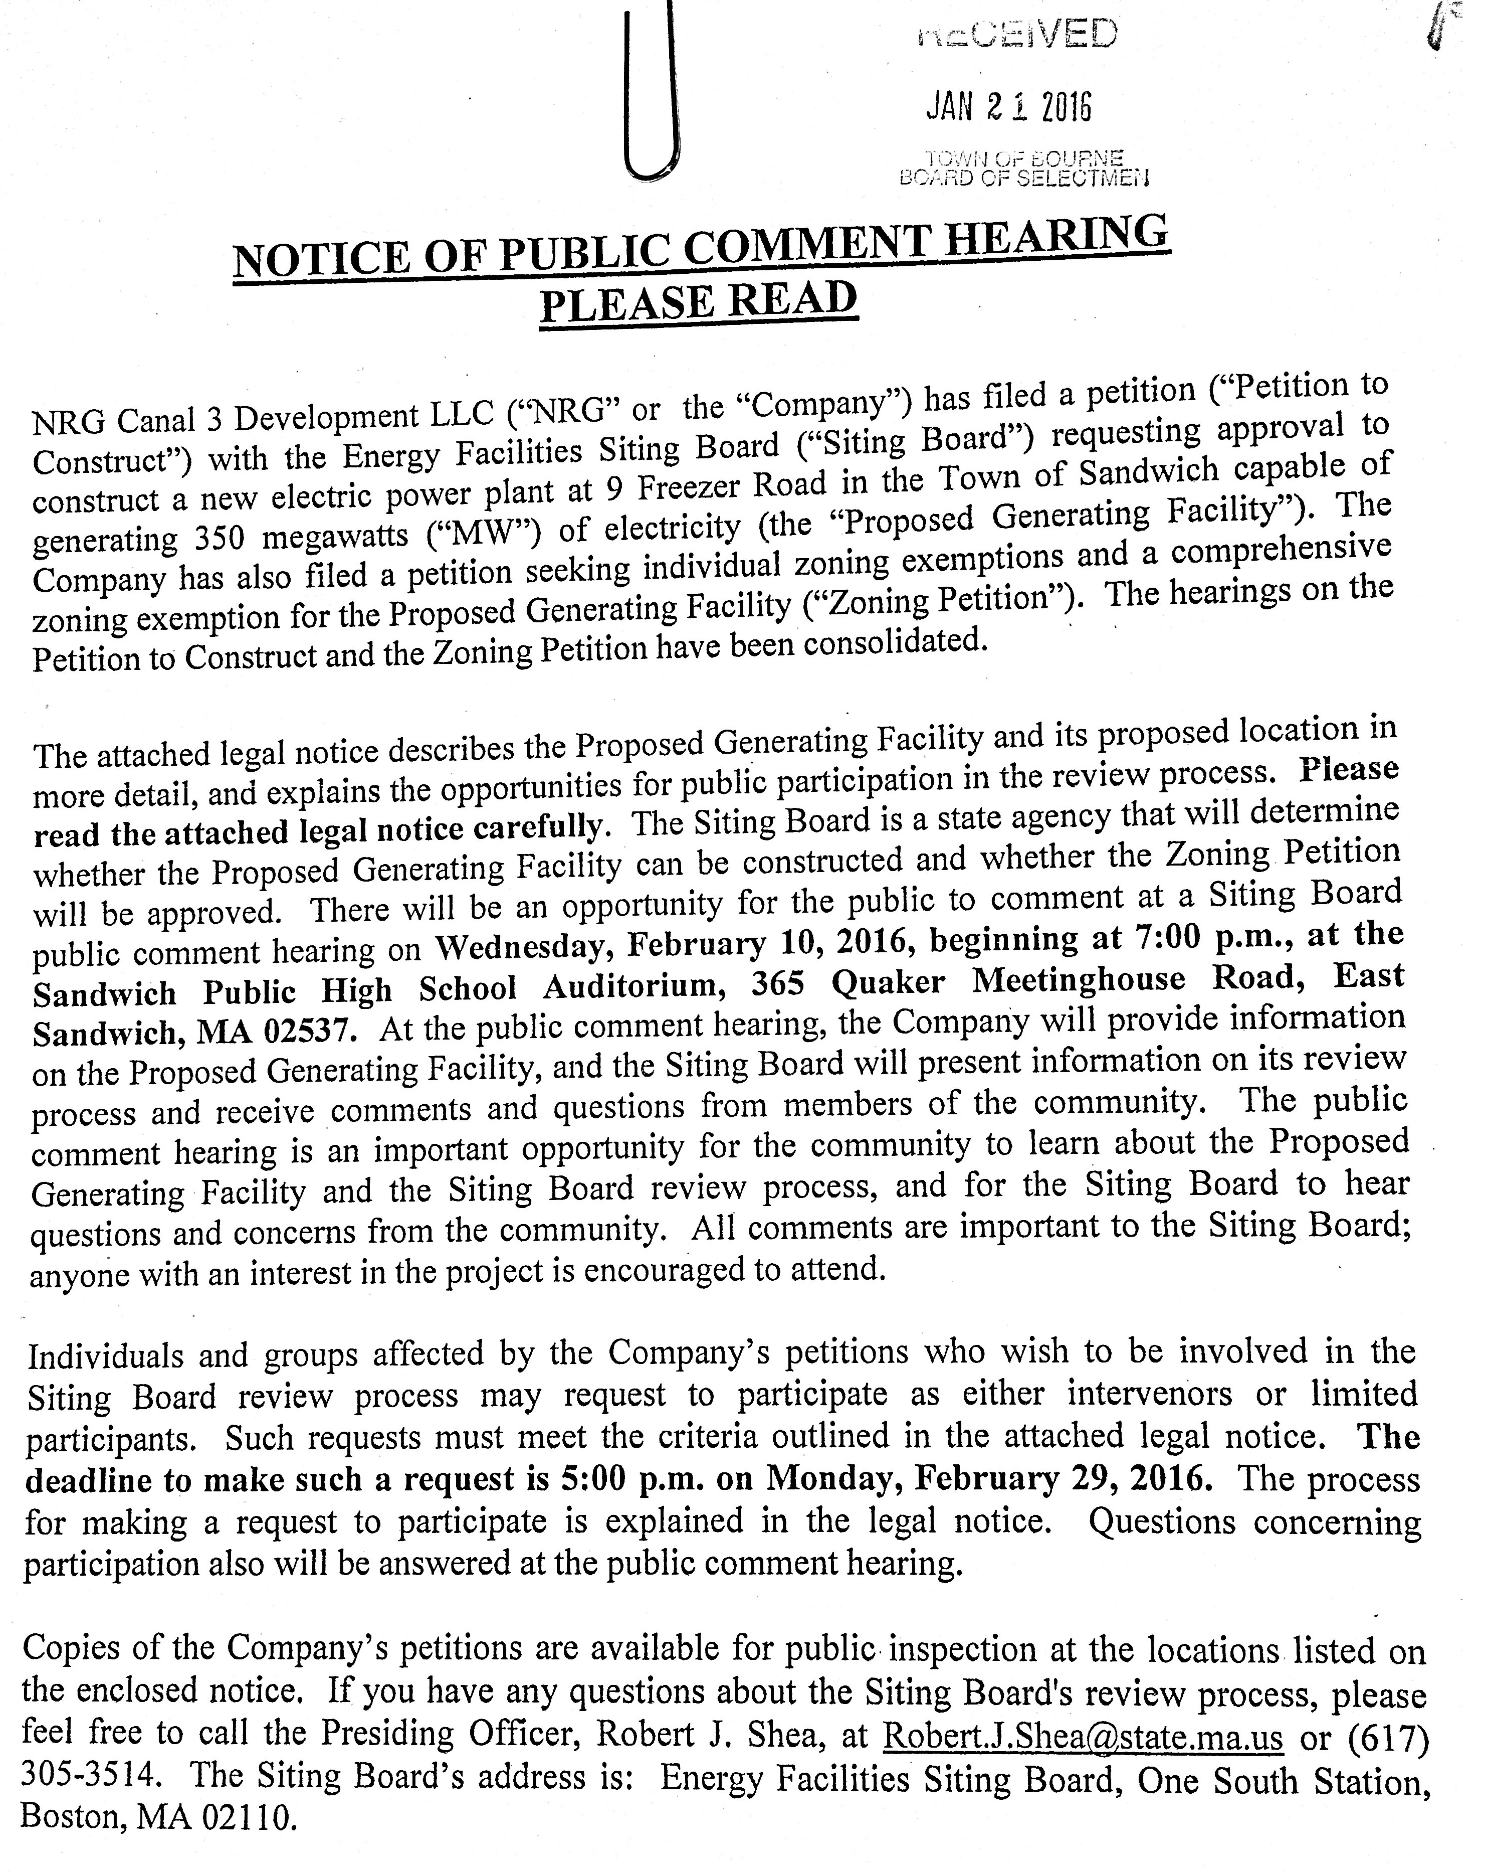

- Notice from Xfinity re: Change of address notification. They have listed a new address. They can be reached at their Government Affairs office at 181 Ballardvale Street, Suite 203, Willimgton, MA 01887, and then copied to two other addresses in Manchester, NH and Philadelphia, PA
- Upper Cape Cod Regional Technical School District Committee minutes of December 10, 2015
- Eversource will begin pruning along power lines during the next 4 weeks
- Letter from Chairman Robert Gray of the Conservation Commission re: Martha Craig Rheinhardt has resigned as a member of the Conservation Commission

Peter Meier wanted to thank Martha Rheinhardt for all she has done for the Conservation Commission. and questioned if there was a thank you letter in their packet. Mr. Guerino stated there will be at the next meeting.

6) Hoxie Update – Allyson Bizer-Knox

Allyson Bizer Knox, Jackie Lane, Scott Fitzmaurice

Jackie Lane, development consultant, gave a brief overview of her background. She stated she has been with the group for about one year, and went over what has been happening with the Hoxie Center, and are looking to go public and raise funds.
They produced a couple brochures; one is the Capital Campaign brochure, restoration, renovation, and renewal. They are going to have a board training session getting everything in order, in order to have the credibility to go to different grant organizations. Mrs. Lane also talked about different donations and foundations they are getting donations from.

Allison Bizer Knox went over the outreach program. They just started their second year of doing outreach STEAM, science, technology, engineering, arts, and math through grant awards. Recently started an after school science club, and have had an overwhelming response. Working with the library to offer an art and music program. Working on summer programs for children of all ages. Working with Quincy College in Plymouth to become a site in the future once we are open to provide GED testing, and also credit and non-credit courses. Getting a list of artist, musicians, and educators, for future programming to offer once we are open.

Scott Fitzmaurice spoke about what they have done. We have had the deed just over six months and over a six-month period to date we have raised over $700,000 including CPC funds. Mr. Fitzmaurice also spoke about the companies that have donated work for the roof and spoke about the flooring, elevators, the bathrooms, sprinkler system, fire alarm system, painting, windows, and other items. We submitted a $250,000.00 matching grant to the Mass Culture Council Facilities Fund, which is a tourism grant. It is about Bourne being a destination. Last week we had a walk through. We have a Mass Historic Grant coming up, and other grants coming up.

Peter Meier questioned based on your CPA appropriations from previous years, how much of those dollars have you spent and what is left for a balance?
Mr. Fitzmaurice stated we are about three-quarters way through both of those grants. We have completed the first grant billing process and are about halfway through the second grant. We now have the grant agreement issued on the second grant, so those funds should be coming fairly quickly.

Mike Blanton stated it was a nice opportunity to be invited to the open house, and being able to get the walking tour.

Don Ellis wanted to state you all are doing an outstanding job.
7) Licenses/Appointments:
  - Capital Outlay Committee – Carol Lynch

Carol Lynch introduced herself to the committee, and gave a brief background of her work.

Voted Peter Meier moved and seconded by Michael Blanton to appoint Mrs. Lynch for the term expiring on June 30, 2016. Vote 5-0.

8) Selectmen’s Business –
  - Review Planning Board Articles for February 8, 2016 Special Town Meeting
  - Discussion of remaining Warrant Articles for the February 8, 2016 Special Town Meeting
  - Selectmen’s Goals as presented by Selectmen Blanton and Meier

Coreen Moore, Town Planner, went over the three articles for the Special Town Meeting that is going to be held on February 8, 2016.

ARTICLE 5. To see if the Town will vote to amend the Bourne Zoning Map by changing the existing Business 2 (B2) zoning district to Business 3 (B3), as shown on a map on file with the Town Clerk, or to take any other action in relation thereto.
Sponsor – Planning Board

Mrs. Moore said that Article 5 is a zoning map change. The proposal is to change a B2 district to a B3 district. This district is located at the Bourne Rotary up on the former Canal Side site. The B3 change will remove a single-family component. It will reserve the area for business development. Residential will be allowed through an open space community with 10 acres or more. It will allow for an increase in building height by a special permit.

Peter Meier questioned what will happen to the 40B that was filed a while ago. Has that application expired yet?
Coreen Moore stated I don’t think there is much time left on that.
Don Ellis said thanks for bring this forward, it I a positive step in the business for this town.
Don Pickard questioned if the planning board has taken a vote on these articles yet?
Coreen Moore stated they will on Thursday.

Voted Peter Meier moved and seconded by Michael Blanton to support Article 5 as presented. Vote 5-0.

ARTICLE 7. To see if the Town will vote to amend the Bourne Zoning Bylaws as follows, or to take any other action in relation thereto:
Add superscript footnote “r” to Zoning District B3 in Section 2500 Intensity of Use Schedule
Proposed | R80^{k,m} | GD^{n}  SDD^{g,n} | R40^{m} | B1^{a,m,p,r}  VB^{a,m} | B2^{j,n,p} | B3^{n, r} | B4^{n}
Existing | R80^{k,m} | GD^{n}  SDD^{g,n} | R40^{m} | B1^{a,m,p,r}  VB^{a,m} | B2^{j,n,p} | B3^{n} | B4^{n}

And to revise footnote “r” to read as follows:
Proposed:
r. Except building height in B-1 & B-3 zoning district increase of allowable height by Special Permit by the Planning Board.

Existing:
r. Except building height in B-1 zoning district increase of allowable height by Special Permit by the Planning Board.
Sponsor – Planning Board

Coreen Moore stated this is a change in section 2500 by adding the B3 to that section to include the height increase in that section, by a special permit.
Michael Blanton questioned what is the max building height?
Coreen Moore stated it is by special permit. They would have to make an argument to the planning board for the height they are seeking; there is not particular height.

Voted Peter Meier moved and seconded by Michael Blanton to approve Article 7. Vote 5-0.

ARTICLE 6. To see if the Town will vote to amend the Bourne Zoning Bylaws as follows, or to take any other action in relation thereto.

Add the following language to Section 2885 c) 1)
(Downtown Sign Regulations)

c) Monument or Freestanding Signs. Monument and free-standing signs are located adjacent to the right of way independent of the building. Monument and free-standing signs must be located outside the sight triangle area so as not to obstruct views of vehicles at the intersection.
1) Monument or freestanding signs are allowed in addition to the primary and pedestrian signs when a building's front entrance is set back at least 15 feet from the street. The maximum allowable height of all signs is eight feet, except that the Design Review Committee may allow up to 12 feet if found that such height is necessary for the site and is compatible with the appearance, scale and character of the area. The sign shall not exceed an area no larger than 30 square feet per sign face, subject to meeting other design criteria.

2) A monument sign shall be set onto a base or frame, presenting a solid, attractive and well-proportioned appearance that complements the building design and materials.

3) A freestanding sign is a sign supported by two or more columns, uprights or braces in, or upon the ground.

4) Height (of a sign): The vertical distance measured from the highest point of the sign to the average ground grade beneath the sign.
Sponsor – Planning Board

Coreen Moore stated this article is a downtown sign regulation section 2885C1 to change the height requirement for the sign from 6 ft. to 8 f.t; and to allow the Design Review Committee to increase to 12 ft. depending on the individual site conditions.

Voted Peter Meier moved and seconded by Michael Blanton to approve Article 6. Vote 5-0.

Peter Meier stated last week when he commented on amending article 11 to put money back into the community building for the purposes of opening the building. It has come to his attention that some people at the library had taken offence to his comment, because they are going to be affected also and they service all ages of people. The intent was the library has money going back into their budget, and the community building didn’t have any money going back into their budget. I’m trying to make sure the money was spread out evenly. Mr. Meier stated I would like to be put on their next agenda so they can speak to me directly.

Stephen Mealy said there is a pre meeting for the town meeting on February 4th at 3:00.

8 c. Selectmen’s Goals
Michael Blanton stated he and Mr. Meier met with the Town Administrator to go over the goals. We are looking to enhance leadership, fiscal responsibility, and policy establishment.
We talked about accomplishments from the previous year that we might like to replicate moving forward, we referenced the formation of the Financial Project Working Group.
We looked at effectiveness and how we can hold better meetings by tightening our agendas, maintaining a mutual respect for other board members, elimination of redundancy, and arriving at a consensus if possible. The carry over goals we looked at were the plastic bag reduction and work on the 208 plan with regard to waste water. Work to continue the continuity services while we continuing good financial stewardship to the citizenry that we serve. We looked at fiscal goals the refining policies, monitoring staffing policies. We looked at areas that touched on environment protection, economic development, and community development, and organizational management as prime goals. Under organizational management we talked about creating efficiencies, restructuring for better efficiency communication amongst departments, and organizational leads for both current and future uses. Economic development continued to look at waste water treatment, monies related to that, how to continue to handle grey water, look at septic capacity, hazards affects on economic development as we know from some of the projects that came forward, that we are reaching that threshold of waste water capacity, so we need to expand that capacity. We talked about siting down with the Town Planner and creating a public viewable catalog of developable land. We talked about enforcement of our existing blithe by law. Under the 208 program the Cape Cod Commission does offer technical assistance we will continue to work with them. With regard to organizational efficiencies we will continue to work towards trying to refine policies and practices. An organizational chart was put forward by the Town Administrator.
Tom Guerino stated there were 2 organizational charts, one existing and one new proposed organizational chart. Mr. Blanton continued under other efficiencies; we talked about centralizing bulk purchasing between departments. Centralizing mailing town wide brought down to Town Hall for cost savings on postage.
Peter Meier spoke about the plastic bag by law.
Mr. Blanton said they also had a discussion with regard to police and fire vehicles and if there is cost saving on leasing rather than buying. The Town Administrator will look into this. Peter Meier spoke about economic development maybe having a separate workshop meeting for the process going forward. We need to bring more development into this town, and to look at where is the money going to come from. After Town Meeting we can look at a future meeting date to talk about that issue.
Mr. Blanton we had a discussion about waster water treatment and expansion; the Waste Water Advisory Group is working on that. The review and inventory of developmental land, and whether GIS interns could be used.
Peter Meier stated maybe Tom can get together with the Chairman as we get into economic development to see who we can bring in to help us drive that issue.
Tom Guerino said he is going to use the Growing Your Business Seminar that he used many years ago.
Peter Meier stated as part of that initiative we need to be looing at budgets. Coreen Moore should be at that meeting when we are discussing the Town Planners budget.
Tom Guerino said if you look at the organizational chart it would fall under the office of planning and development.

9) Town Administrator’s Report
Budget FY17 – Labor negotiations

Tom Guerino stated as I have said before we have eight bargaining units we need to negotiate with prior to the end of fiscal year and hopefully have many of them concluded by town meeting. I would ask the selectmen to give me some parameters. The charter provides that I negotiate all contracts on behalf of the Board of Selectmen. If the town meeting concludes in one evening I would suggest we post a meeting prior, to meet on Feb 9th. If the town meeting were to extend into the next evening we could cancel that meeting and schedule it for another evening. On Feb 2nd we have issues related to other health related contracts and that would be an executive session. Stephen stated how about 7:00 on Feb 9th. Tom Guerino will post that meeting.

Stephen mealy questioned the Finance Chairman, we have made a great deal of progress on reviewing the entire budget in preparation of supplying it to the Finance Committee, by the requirements of the charter on the 1st or 2nd of February. I would like to ask if you would address your board and push that off until Feb 17th, that will give us an additional 2 weeks to undertake final reviews before making a final recommendation.

Mary Jane stated the financial schedule will depend on the vote at town meeting. If there are any materials the Finance Committee could get ahead, long term projections debt schedules, other material we can get in advance, it will be helpful. It is likely we will not meet to start reviewing the budget until Feb 17th at the earliest. Stephen Mealy stated we might be able to put together a preliminary booklet that covers many of the smaller departments. Mary Jane stated we are on a tight schedule. The Finance Committee would prefer the budget be as complete as possible before it comes to the Finance Committee. Then we will schedule according to that. Peter Meier stated he has met with all departments with the exception of the Upper Cape Tech School and will be working on getting that done in the next week

10) Selectmen’s Reports
Peter Meier stated he attended a Bourne men’s basketball team, they lost to the Old Rochester Regional team. We met with the department last week. We may meet with them again to get some clarification.

Don Pickard said he went to the Mass Municipal Association Conference and Trade Show. He got out of it that regional dispatch is probably not a good thing. If we get in a position to do it ourselves we would probably be better off. Got some good ideas for how we can move along.

Mike Blanton wanted to mention that the roads of Bourne were phenomenally well kept from the storm.

Don Ellis agreed the DPW did an outstanding job on the roads and sidewalks.

Stephen Mealy elaborate on the MMA meeting. There was a presentation by the Fire Department and the Town Manager on regional dispatch. It was two towns that were not next to each other working dispatch electronically between each other. When they got into the financial presentation for how this was done, a lot of money was brought in through grants. If it hadn’t been for the grants they wouldn’t be doing it. Mr. Mealy stated he attended the Waste Water Advisory Committee meeting last week. There was an overview of the grant that was just received by the Buzzards Bay Coalition addressing wastewater needs for Buzzards Bay, Southern Plymouth, and getting into Wareham. They are going into a supplemental grant to now include Marion. This would tie together Wareham’s plan. It would eliminate Mass Maritime treatment plant and extend seweraging into around Buttermilk Bay and into Plymouth. The initial kickoff would be the 100,000-gallon per day treatment plant, which will be put into Queen Sewell Park to attend immediate needs, and the rest of this process will be brought on over the next ten years. I have asked them to come back to us in the spring with more information. We received a verbal notification from Compassionate Care; they proposed to put in a marijuana cultivation center at the old Grand Union location off Clay Pond Road. They indicated they may withdraw their application. There is a meeting scheduled for February 2nd. Also the DPW did a great job.

11) Other Business that may legally come before the Board

The next Bourne Selectmen meeting will be on Tuesday, February 2nd at 7:00 P.M.

12) Adjourn

Voted Mike Blanton moved and seconded by Don Pickard to adjourn. Meeting adjourned at 8:15 pm. Vote 5-0.

Respectfully submitted – Carole Ellis, secretary.

