TA Guerino

Selectmen
Stephen Mealy, Chairman
Don Pickard, Vice-Chairman
Michael Blanton, Clerk
Don Ellis
Peter Meier

Note this meeting is being televised and recorded. If anyone in the audience is recording or videotaping, they need to acknowledge such at this time – Michael Rausch Bourne Enterprise and Paul Gately Bourne Currier.

All items within the meeting agenda are subject to deliberation and vote(s) by the Board of Selectmen.

Documents

Meeting Called to Order
Chm. Mealy called the meeting to order at 6:34 pm.

Moment of Silence for our Troops/Salute the Flag

Public Comment – Non-Agenda Items
None requested.

4) Joint Meeting with Conservation Commission and Planning Board to discuss the sale of surplus property (25G) Hideaway Village)

Conservation Committee Members present were: Thomas Ligor, Bob Gray, Elizabeth Kiebala, and Paul Szwed.

Tom Guerino went over the information on the property at 25G Hideaway Village. We are trying to get this property on the auction list. We need to get permission to sell this property from the Conservation Commission and the Planning Board.

Voted Don Pickard moved and seconded by Peter Meier to sell the surplus property known as at 25G Hideaway Village by Auction. Vote 5-0.

The Conservation Commission made a motion to put the property up for sale. The motion carried.
The Planning Board made a motion to put the property up for Auction, 25G Hideaway Village. The motion passed.

Conservation Commission and the Planning Board adjourned and left at 7:40 pm.

5) Minutes

Postpone until the next meeting.

6) Correspondence

Don Pickard brought the committee up to date on the correspondence.

- Letter of resignation from Thomas Armstrong as a member of the Board of Appeals
- Letter of interest from Kat Brennan requesting appointment to the Board of Appeals
- Public notice: US Army Corp of Engineers received permit application to conduct work in the waters at 101 Academy Drive, in Buzzards Bay
- Received a copy of a letter that was sent to Henry Donovan, President, Monument Beach Sportsman’s Club to discuss the safety mitigation for Army personnel and their contractors that work within the down range area of their Long Rifle Range
- Town Administrator’s Police Facility Building Committee – Membership and Charge
- Upper Cape Cod Regional Technical School submitted Total Assessment to the Town of Bourne in the amount of $3,294,382.00
- DEP (Department of Environmental Protection) Affirms the Harbor Master’s decision to deny a 10A permit application to Thomas McDonald
- Letter from DEP regarding 428 Barlows Landing Road, Pocasset
- Letter of interest from Timothy Sawyer requesting appointment to the Board of Appeals
- Letter of interest from Amy Kullar requesting appointment as Associate member to the Board of Appeals
- Mass Fiscal Alliance advocates for better fiscal policies that may affect the Town of Bourne
- Elder Services 3rd quarter meal statistics for January, February, and March 2015
- Division of Marine Fisheries: Closed to shellfishing – Monument Beach Marina, Pocasset Harbor (Barlows Landing), and Red Brook Harbor
- Letter from DEP regarding Queen Sewell, Provisional Approval of Hydrogeological Evaluation Report
- Amended Correspondence: Michael Blanton submitted letter of resignation as Bourne’s Representative to the Cape Cod Commission

Stephen Mealy requested letter “E” to be read.

Tom Guerino read letter “E” Town Administrators Police Facility Building Committee Membership & Charge to understand the membership and charge.

Stephen Mealy briefly went over the dollar amount for the Upper Cape Cod Regional Technical School.

7) Signing of Bond Anticipation Note (BAN)

Tom Guerino went over the Bond Anticipation Signing and what it will cover, roadway and retaining wall - $220,000, equipment - $95,000, school repairs (elevator) - $60,000, school feasibility study - $50,000. He recommends the Board of Selectmen accept the bid from Century Bank.

Voted Don Pickard moved and seconded by Peter Meier to accept the bid from Century Bank as described in the memorandum from the assistant treasurer dated June 5, 2015. Vote 5-0.

10) Licenses/Appointments:
a. One Day Liquor - National Marine Life Center Event
1. [7.4.15] – Cape Cod Beer –- Wine & Malt
2. [7.5.15] - National Marine Life Center –Wine & Malt
b. National Marine Life Center – Arts & Crafts Fair, food vendors, local business booths, music at the bandstand, kids activities (7 rides)
c. Three [3] One Day Wine and Malt Liquor Licenses for the Sagamore Beach Colony Club
d. 4th of July Parade
e. Bourne PTA – Request waiver of use of park fee – 10.4.15 Event
f. License for the Cataumet Club, Inc. for a seasonal wooden swim float in Squeteague Harbor
g. Bourne/Wareham Art Association request waiver of fees for both the use of the park and liability insurance.

Don Pickard went over the licenses.

10 a-1) Cape Cod Beer, Inc. (Caterer) in Hyannis having a function on July 4th from 10am to 6pm, at the National Marine Life Center Event, for a beer tent. Permission to allow sale of alcoholic beverages on town property at an event to be catered by Cape Cod Beer. The comments are DPW: They need to make arrangement for trash removal. Police Department: They must comply with all liquor laws. Detail officers are required. Mr. Guerino stated that the beer will only be served from noon to 6 pm.

Voted Don Pickard moved and seconded by Peter Meier to approve based on a completed application. Vote 5-0.

10 a-2) National Marine Life Center for a one day wine and malt beverage license for an enclosed area in a tent to be held on July 5th from 11am to 6pm. Application appears to be complete. We have the insurance binder. Board of Health: The only comments are that any food vendors will need to be licensed thru the BOH. Stephen Mealy stated that there is also a comment that an officer will be required.

Voted Don Pickard moved and seconded by Michael Blanton to approve based on a completed application. Vote 5-0.

10 b) National Marine Life Center arts and craft fair food vendor, local business booths, music at the bandstand, kids activities and tents. On July 3rd setup at 8:00, Saturday July 4 from 7am to 8pm and on Sunday July 5 from 7am to 6pm. Estimated attendance of 2,000 people. The police Department had written comments.

Voted Don Pickard moved and seconded by Don Ellis to approve based on a completed application with diagram as well as the certificate of liability. Vote 5-0.

Peter Meier questioned having food vendors in front of the food business.
John Ford explained who the food vendor are and where they will be located.

10 c) Sagamore Beach Colony Club annual request for 3 one-day liquor licenses for beer and wine only. It will be on 7-18-15 from 5:00pm to 11:00pm for a family night, on 8-14-15 from 6:00pm to 11:00pm for a corn hole tournament and on 8-9-15 from 6:00pm to 11:00pm for Oktoberfest annual fundraiser. The application appears to be completed. The Fire Department’s comment is “Has to be under 100 people or crowd manager and sprinkler system will be required”.

Voted Don Pickard moved and seconded by Don Ellis to approve the one day liquor licenses for beer and wine only for the Sagamore Beach Colony Club. Vote 5-0.

10 d) July 4th parade submitted by Jennifer Kennedy. The parade will be from Academy Drive down Main Street to Perry Avenue. The Board of Health commented that any food vendors need to contact BOH for licenses. Anything to do with trash please contact Mr. Sala.

Voted Don Pickard moved and seconded by Michael Blanton to approve based on a completed application. Vote 5-0.

Peter Meier questioned the placement of the banner. He was told by the organizer, the banner needs to be relocated, where it has been in years past it cannot be there anymore. Mr. Guerino stated he wasn’t aware of that and he will try to accommodate as much as possible.

10 e) Bourne PTA request to waive the $100 rental fee for the Buzzards Bay Park.

Voted Don Pickard moved and seconded by Michael Blanton for the Town of Bourne through the Board of Selectmen to approve the waiver of the fees of $100 for the PTA for October 4th 5k Family Fun Day in Buzzards Bay but the Town will require a deposit which will be returned once the park is returned to its normal condition as identified by Mr. Sala. Vote 5-0.

10 f) Mr. Guerino explained it is a 5-year license agreement, a renewal on the Cataumet Club to place a wooden float in Squeteague Harbor. Insurance is in place.

Voted Don Pickard moved and seconded by Michael Blanton to approve the request from the Cataumet Club to place a wooden float in Squeteague.

Mr. Mulvey questioned if it was approved by the Harbor Master.

Amended Motion - Voted Don Pickard moved and seconded by Michael Blanton to approve the placement of a wooden float in Squeteague Harbor by the Cataumet Club, Inc. for the upcoming beach season contingent upon the approval of the Harbor Master Vote 5-0.

10 g) Request from the Bourne/Wareham Art Association requesting waiver of fees for
both the use of the park and liability insurance. Mr. Guerino recommended not to
waive the liability insurance.

Voted Don Pickard moved and seconded by Michael Blanton for the Board of Selectmen to waive the $100 fee for the Bourne Wareham Art Association. I further move the Board instruct the Town Administrator to collect the deposit, which is returnable upon the condition of the park being examined by the Department of Public Works, but not to waive any liability insurance and require liability insurance. Vote 5-0.

8) Hoxie Historic Restriction

Tom Guerino explained this is part of the of the 3 or 4 contingencies relative to the transfer of the property at Hoxie going from the Town to the Hoxie Group. Should the Board approve this this evening, at the next meeting it is anticipated we will have a deed that Town Counsel will have prepared so that we can close this loop, and we will successfully be able to transfer this property.

Jon Nelson went over the Hoxie Historic preservation restrictions. MHC, Town Counsel, and the Hoxie Group has approved it.

Voted Peter Meier moved and seconded by Don Pickard to authorize to sign the Hoxie Reservation Restriction. Vote 5-0.

Voted Don Pickard moved and seconded by Peter Meier take a 5-minute break.
Vote 5-0.

7:20 Chairman Mealy called the meeting back to order.

9) Hoxie Deed signing
CONVENE JOINT SESSION WITH FINANCE COMMITTEE AND SCHOOL COMMITTEE
  - Review Annual
  - Discuss and establish dates for Override Ballot and Town Special Town Meeting
  - Discuss preliminary override amount and amount of FY16 (17) reductions if override question does not prevail.
  - Adjourn.

a. Review Annual Town Meeting
The Finance Committee didn’t have a quorum, so they didn’t call their meeting to order.
Present for the Finance Committee were Chairman Mary Jane Mastrangelo, Vice-Chair John Redman, George Slade, Brian Lemee, Kathleen LeGacy, Bill Towne.

Present for the Bourne School Committee were Christopher Hyldburg, Anne-Marie Siroonian Heather DiPaolo, Laura Scena, and Judy Froman.

Stephen Mealy wanted to have a review of the Annual Town Meeting, relative to the preparation and the Town Meeting itself, and open the floor to any comments.

Mary Jane Mastrangelo stated that the budget support documents were helpful and should be included in the budget presentation. The updated sources and uses provided information that is useful and the free cash analysis was helpful, the long term projection model should be included at the budget presentation so we see the impact of the budget, and the FTE analysis was useful. The joint meeting with the Board of Selectman and the Finance Committee is helpful for communication.

Stephen Mealy also questioned if there is anything that could be added or should be added for the future.

Chris Hyldburd stated the Finance Project Working Group was good to help the superintendent and give him the feedback he needed to establish and inseminate the budget.

- Discuss and establish dates for Override Ballot and Town Special Town Meeting
From the discussions with the Board of Selectmen, Finance Committee, and School Committee members the following is the calendar as adopted by the Board of Selectmen.

Working Override Schedule
June 09, 2015 as Adopted

May 28th

- Department Heads meet with T/A to discuss override and reduction proposals to be brought back to the T/A in the amounts of 5, 10, and 20%.
- This group to be advisory to the T/A on budget reductions.

June 8th –

- Review time line and make recommendation to BOS.
- Financial Project Working Group (FPWG) will review long-term projections and advise a preliminary override amount and preliminary reduction amount to be recommended to the BOS for their June 9th meeting.
  - Should this be a joint meeting with Override Working Group (OWG) to agree on starting-point and who is going to do what?

June 9th
- Joint meeting with FinCom, School Committee and BOS to discuss above
- BOS to vote on date of Ballot vote and STM.
- BOS to vote on preliminary Override and Reduction dollar amounts
  - Currently 1.3 million (half year) or $2.6 million full year reduction with a $2.9 override
- BOS adopts schedule for Override evaluation.

June 15th
- FPWG to finish review of Financial Policies and vote recommendation to be presented to BOS/FinCom.

June 23rd
- BOS reviews FPWG Financial Policy recommendation, 1st reading
  - Possible joint meeting with FinCom for Financial Policy review?

June 23rd – August 25th
- Community Outreach

June 24th
- School Committee Budget Workshop

June 29th
- FPWG to review and discuss Long-Term Financial Plan (LTFP) and look at different scenario i.e., 5-year with OPEB and Capital vs. 3-year without OPEB and Capital
- How to deal with military aide
- Vote recommendation to be forwarded to BOS and FinCom.

July 13 -14th
- FinCom and BOS Year End transfers and Reserve Fund closeout meeting.
  - Possible Joint meeting on either day.
- BOS Preliminary Review of departmental Proposed Reductions presented by T/A
- BOS Second Reading, discussion on Financial Policies
- Initial discussion LTFP
  - Joint with FPWG or add School Committee?

July 15th
- School Workshop

July 28th -
- BOS second review of Proposed Reductions
- BOS continued review of Long Term projections and Override amount
- Third reading and vote on Financial Policy
  - Possible Joint meeting with FinCom for this purpose?

August 11th
- FinCom/BOS Joint Meeting to review two new Sources and Uses
  - Sources and Uses with Override
  - Sources and Uses with reductions based on input from July 28th meeting and year end
- BOS Vote on override dollar amount for ballot question

August 25th
- BOS continue departmental reports on budget impacts
- BOS votes on Proposed Reduction amount for FY16 budget if override doesn’t pass (no later than September 8)

September 8th – October 6th
- Public Education on Proposed override and Budget Reductions

September 8th
- Reductions finalized if not already done and public informational presentations begin

October 6th
- Special Town Election for Override Tuesday October 6, 2015

October 19th
- Special Town Meeting Monday October 19, 2015

Voted Peter Meier moved and seconded by Michael Blanton to set the override election for October 6 2015 and the Special Town Meeting for Monday October 19, 2015.

c. Discuss preliminary override amount and amount of FY16 (17) reductions if override question does not prevail.

Stephen Mealy stated this is a proposed preliminary override in the amount of 2.9 million dollars. It would insure the ability of the town not to raise any additional funds by any additional overrides for the next five years.

Linda Marzelli went over the Financial Scenarios.

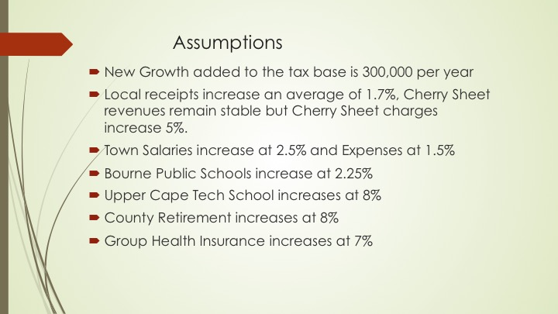
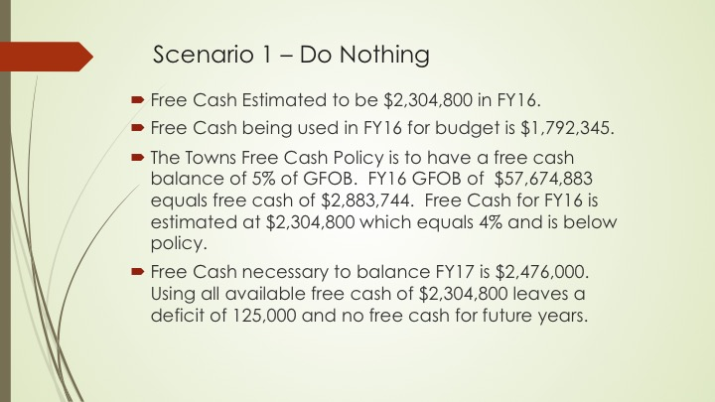
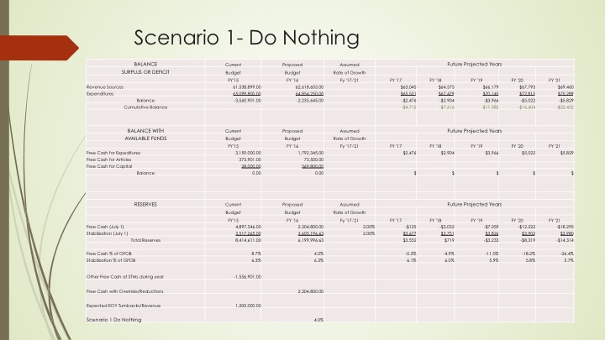
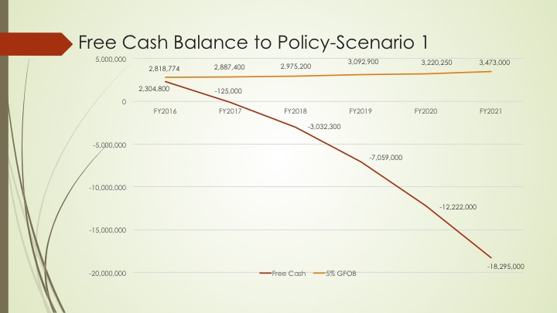
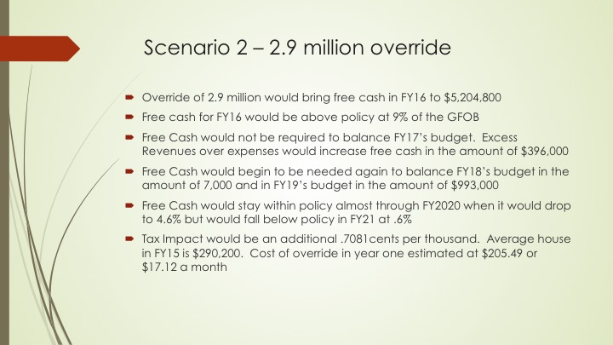
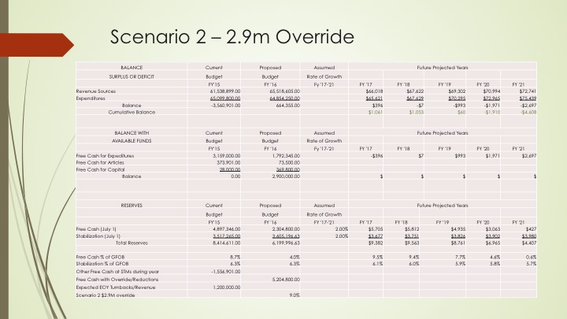
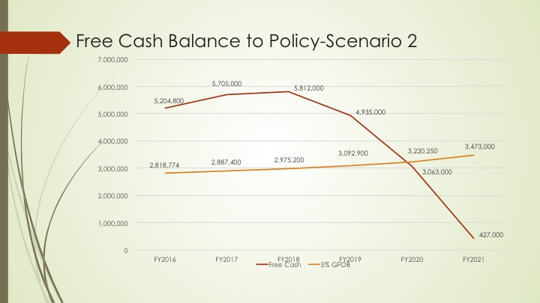
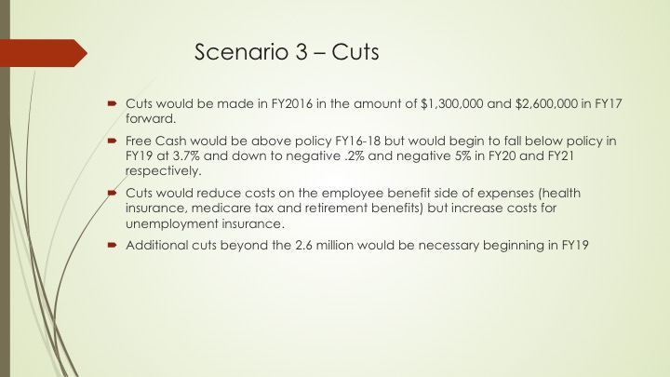
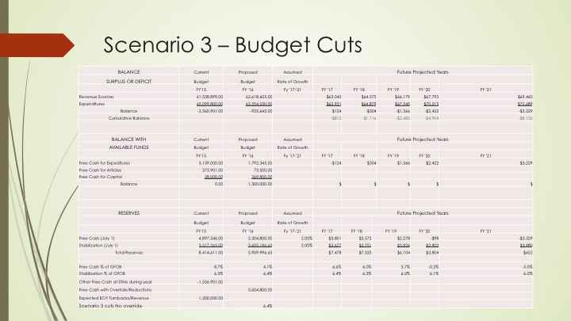

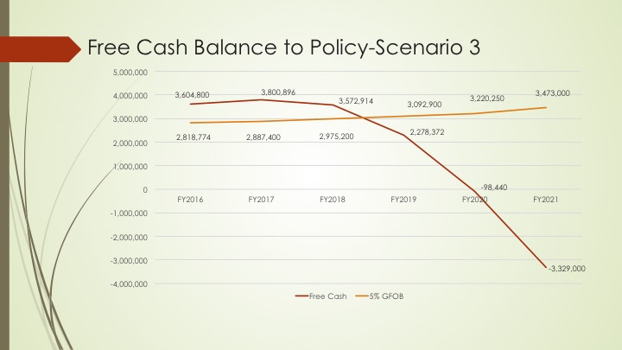

George Slade suggested we explain what free cash is and how it affects the Town’s budget?

Don Ellis suggested we have to state how we got into this position and how we are going to prevent it from happening again.

Stephen Mealy asked the Board members to take a vote for a preliminary override figure of 2.9 million and a recommendation for a preliminary cut in fiscal year 2016 for 1.3 million dollars and a preliminary cut in fiscal year 2017 for 2.6 million dollars as a starting point with the understanding that these numbers may change.

Don Pickard stated this is not an endorsement of the numbers it is just stating for the public that this is what the Financial Planning Working Group has brought forward at this time.

Mary Jane Mastrangelo stated this is the beginning of the process it is by no means the approval of that amount of override or that amount of cuts.

Stephen Mealy restated the suggested motion: for the Board of Selectmen to approve a preliminary override amount of 2.9 million dollars and a preliminary reduction in 2016 of 1.3 million dollars and a preliminary reduction in 2017 of 2.6 million dollars.

Don Pickard suggested to use the verbiage to acknowledge that this is the preliminary number necessary to move forward

Mary Jane Mastrangelo suggested to use recommend a preliminary number of 2.9 million.

Voted Peter Meier moved and seconded by Michael Blanton to recommend a preliminary override amount of 2.9 million dollars and recommend a preliminary reduction in 2016 of 1.3 million dollars and recommend a preliminary reduction in 2017 of 2.6 million dollars. Vote 5-0.

11) Adjourn

Voted Don Pickard moved and seconded by Peter Meier to adjourn. Meeting adjourned at 8:54 pm. Vote 5-0.

Respectfully submitted – Carole Ellis, secretary.

The next Bourne Selectmen meeting will be on Tuesday, June 23rd at 7:00 P.M.

